**1/28/2019**

* Homework 1 creating grids using different methods

**2/4/2019**

* Create grids
  + Minimum curvature is the best method
  + “Average” method
  + Clear and legible fonts
  + Contour intervals thicker lines
  + Make sure thickness is warm colors and thinnest is cooler colors
* To change layer labels
  + Right click Overlay Layers
  + Click read only layers!
  + Update layer data
    - text size
    - 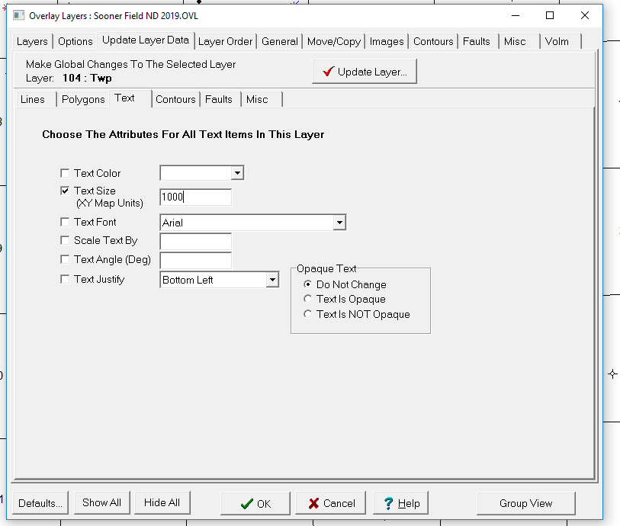
  + Plus sign on left WSN List
    - Add Wells with Digits, rasters, etc
* Click Wells then
  + on Formation Top
  + Bottom click on Aliases
* Recontouring
  + Use Pencil symbol on right side
  + Contour
  + Turn off line of overlay
* Countour → control points → add
* **Homework 2**
  + 1. Add faults → where there are steep dips or nose… on east side
  + 2. Manipulate contour points
  + 3. Manipulate contour lines
  + Make sure to be clear on where you changed it. Before After

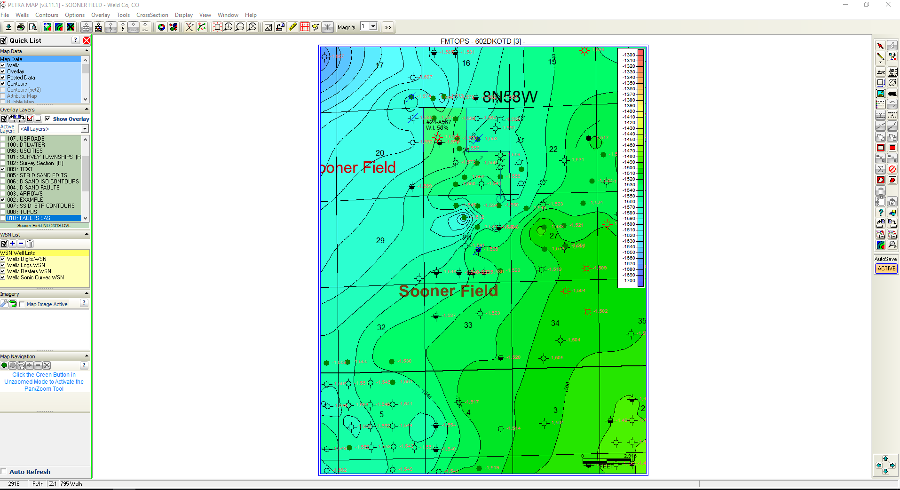

**2/11/2019**

* Bubble maps
* Pie buble maps
* Cross section
  + Raster logs
  + 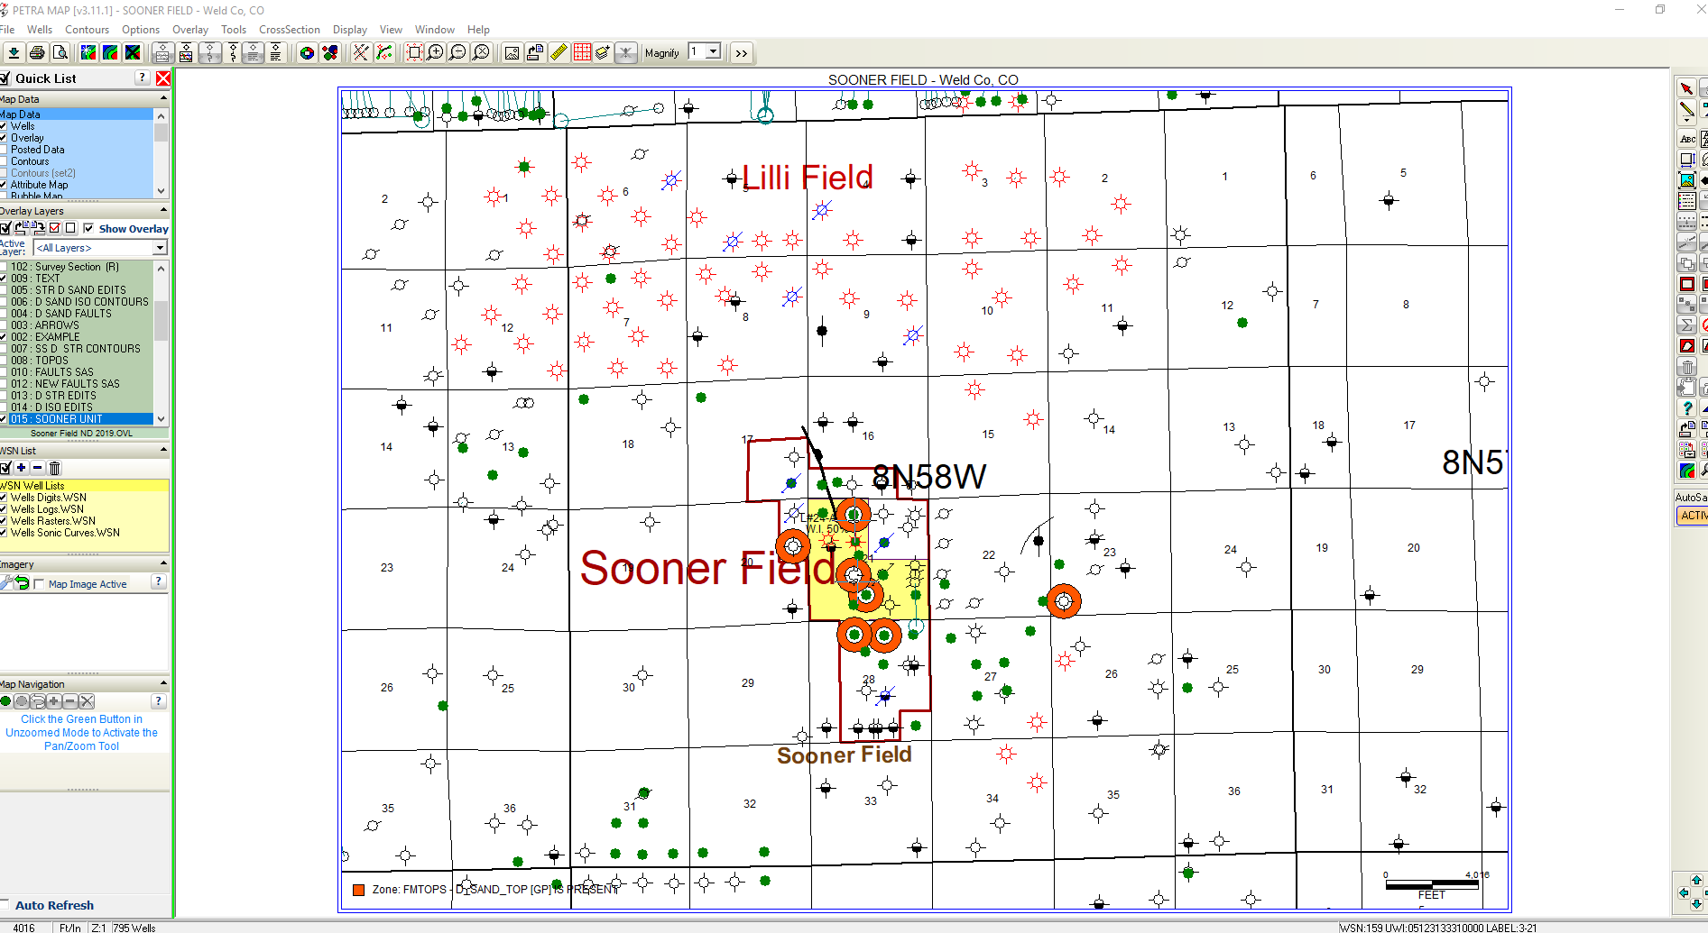
  + Cross section depths → change font settings
  + 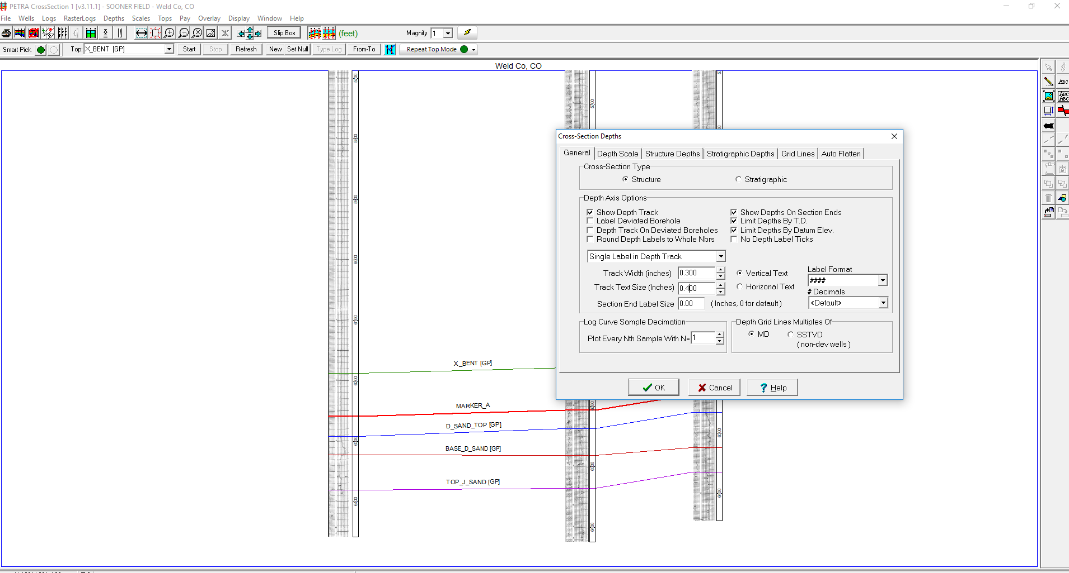
  + Depth Scale (play with numbers), Scales → depth
  + 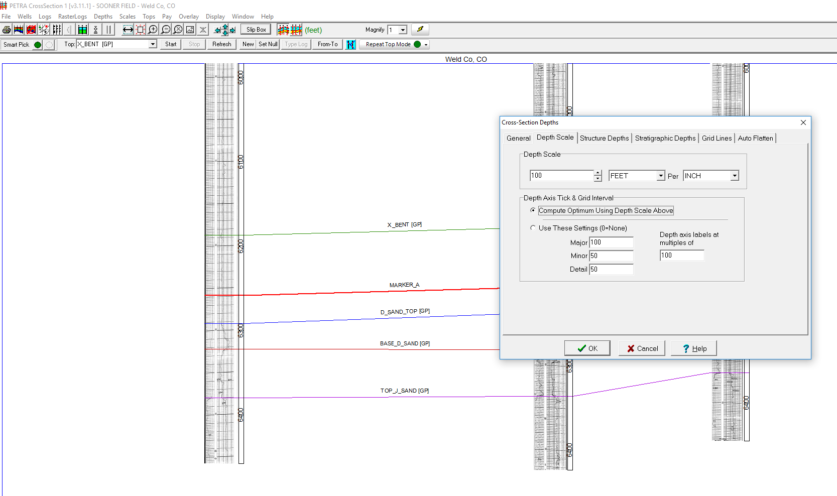
  + 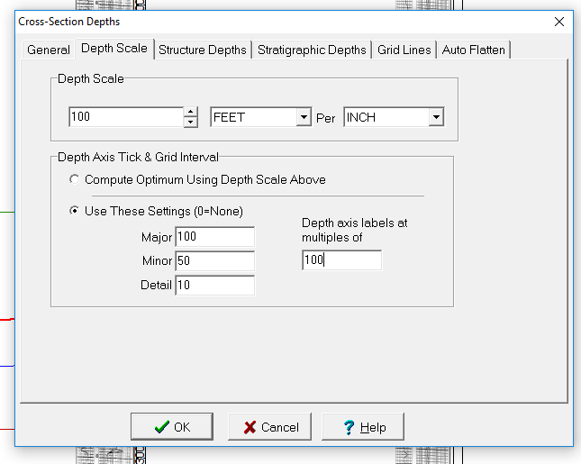
  + 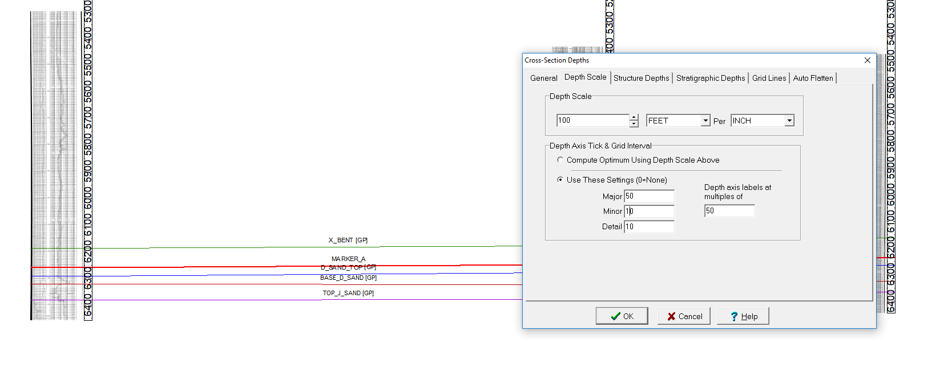
    - Just use second button commpute optimum etc
  + Raster log → Log images to display
    - Resistivity in track 1
    - Porosity in track 2
    - 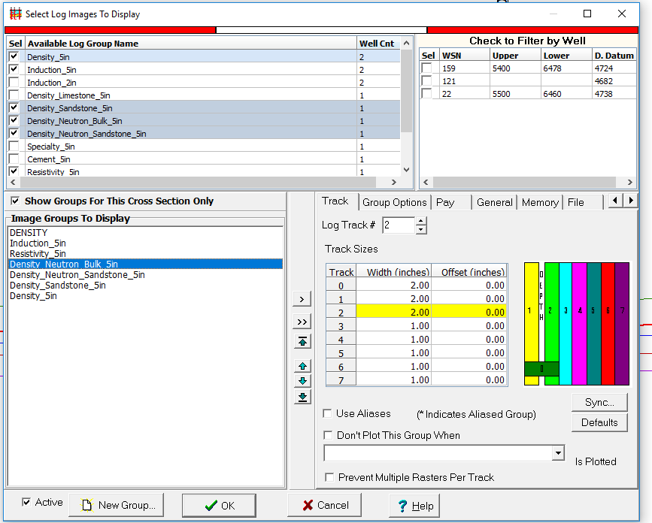
  + 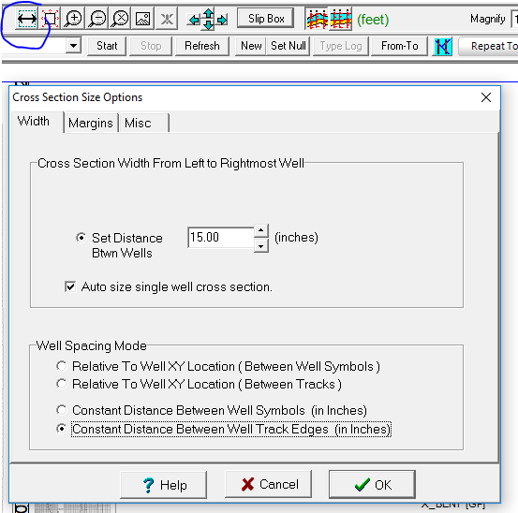
    - Click 2 inches not 15
    - 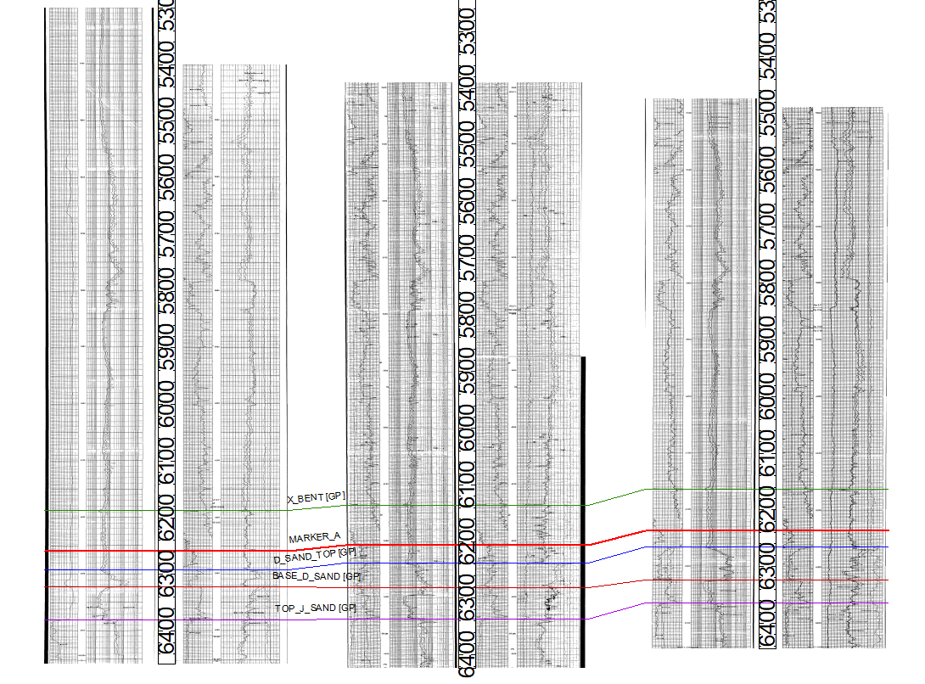
  + Now get in GP Top, Tops → display options
    - 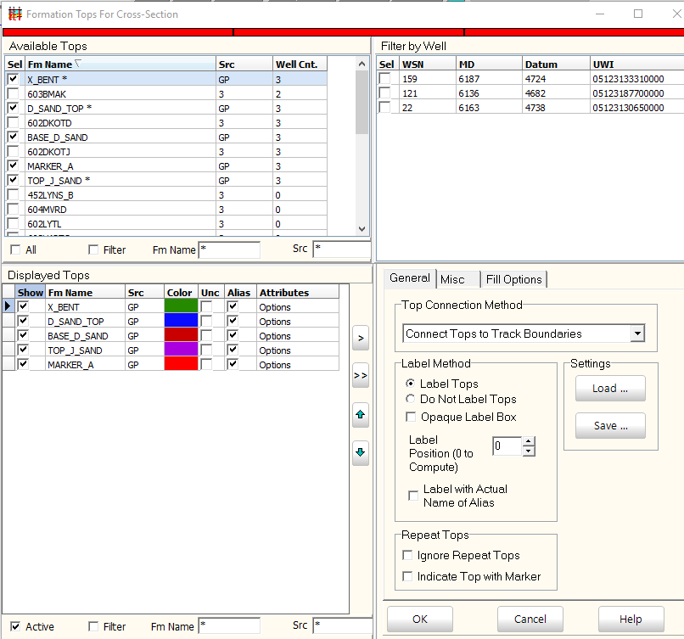
    - You can move marker a right below x bent and change the colors (all black exept orange x bent)
    - 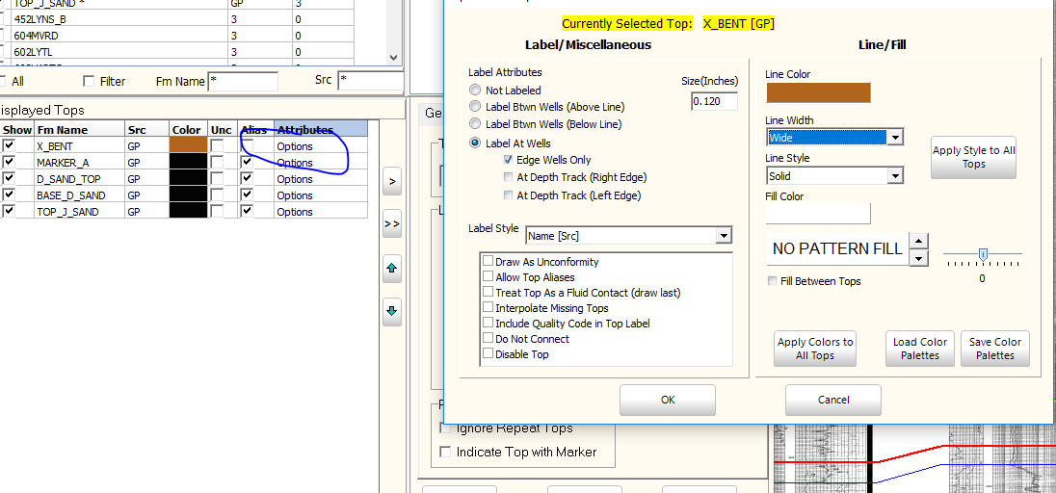
    - Click on options then apply to all
    - 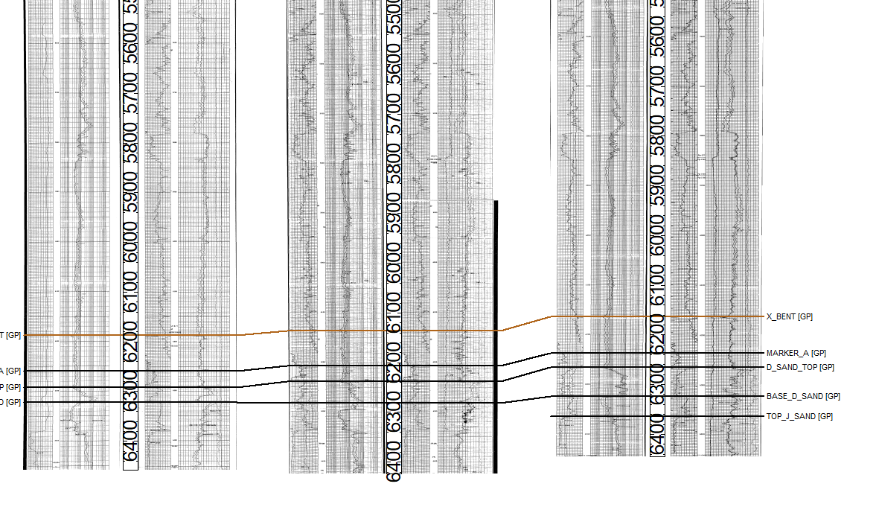
    - Wells → Data posted by Wells spot.. Put things above or below the symbols
    - Add new tops
      * X bentonite, d sandstone, hunstman shale, mowry, jsandstone
    - Tops → display options → check on new tops and reorder to geology
      * 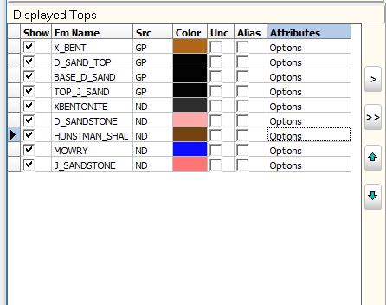
    - Tops → only show displayed tios ub tios toolbar (check)
    - Options
      * 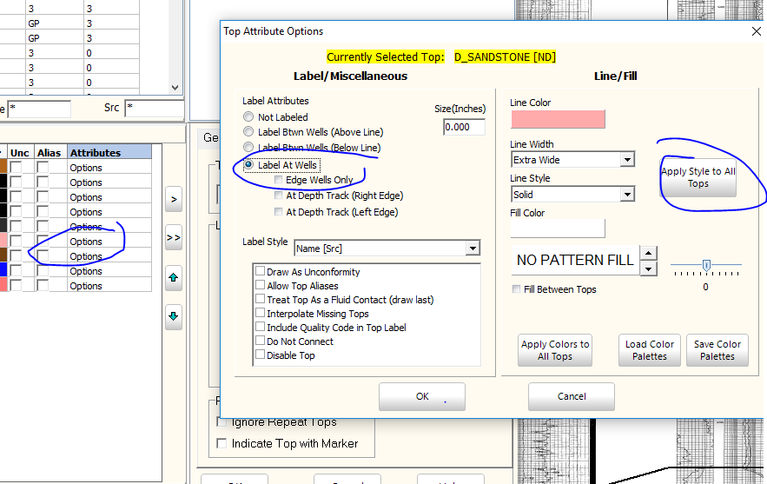
    - Now get rid of GP tops and only check your tops (nd)
  + Now pick your own tops → x bent or graneros and start
    - 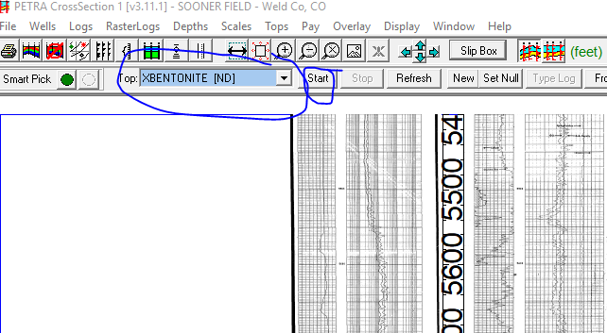
  + Then pick your tops
    - 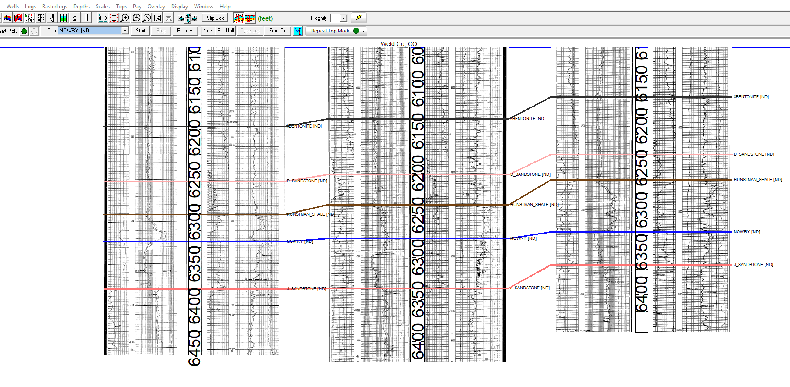
    - To repick,, use start then repicked
      * Or use “smart pick” button → hold control button, drag the pick and then → click redraw
  + To save, File → cross section OR template (save “raster template” under SoonerField PARMS...Then resave
    - Then file → load template → browse →’Raster template”
  + Right click right aboe the middle well on the d sand then click → flatten on D
* Scale depth
  + 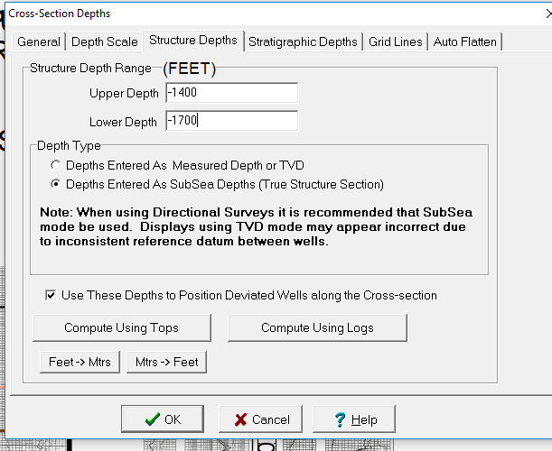
  + **HOMEWORK**
    - Every well picked 9 boxes around box 21
    - All wells have to be picked
    - 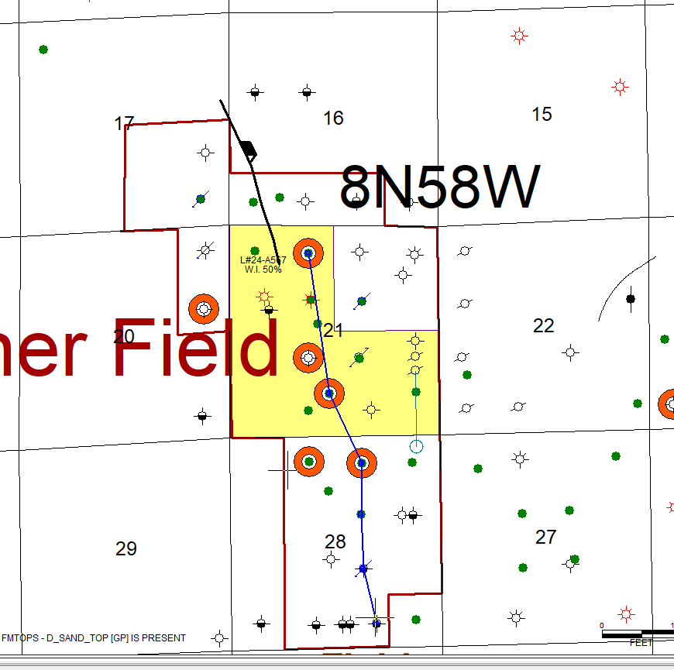
    - To change font title → click wells → post data around symbols then text size is .3 then → all
    - Click the <-> to expand wells if theyre too close together
    - Raster Logs → Set all wells to raster
    - If you wanna show sclae at image bottom
      * 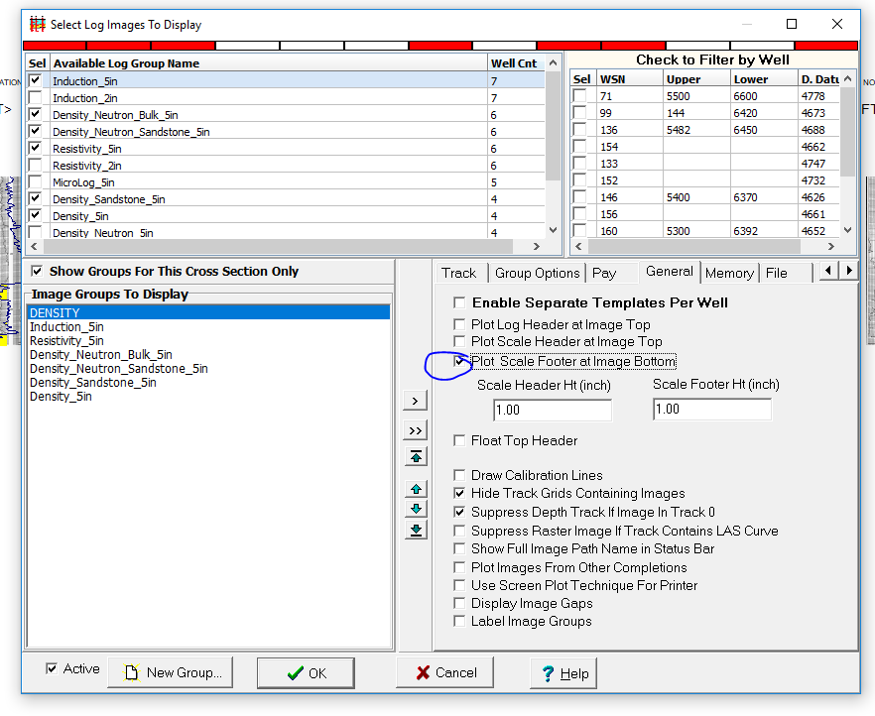
* Now work with DIGIT LOGS
  + 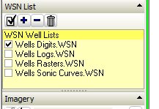
  + lOGS → Scales and Display Options
  + Logs → tracks
  + 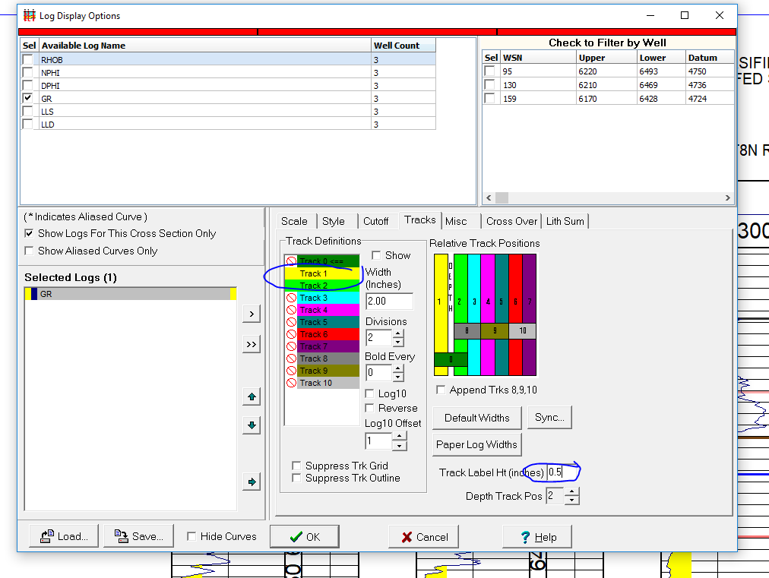
  + Add resistivity
    - Logs → scales → select LLD
    - 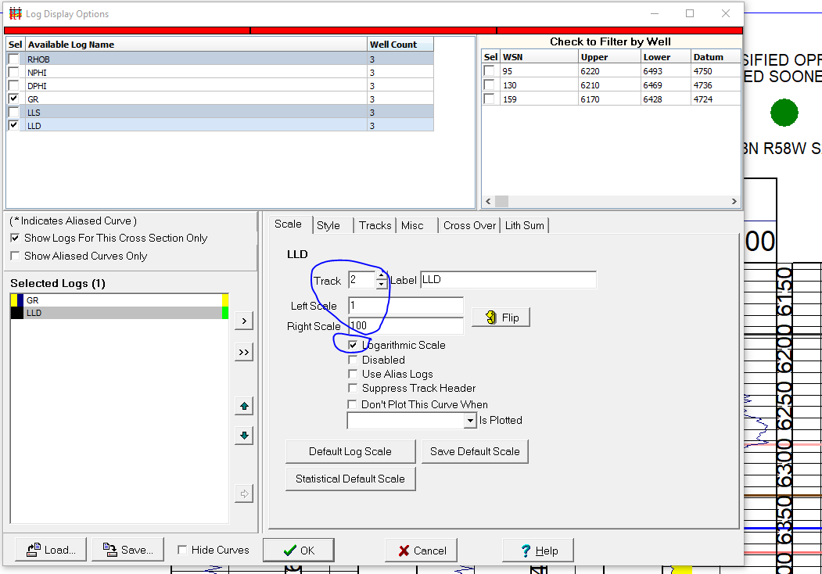
  + Shading on GR
    - Logs → Scales and display
    - Set as no Shading and make Wide
    - Style → shade using cuttoff → less than 100 → shaded yellow
    - Shows Pure Sand!
    - 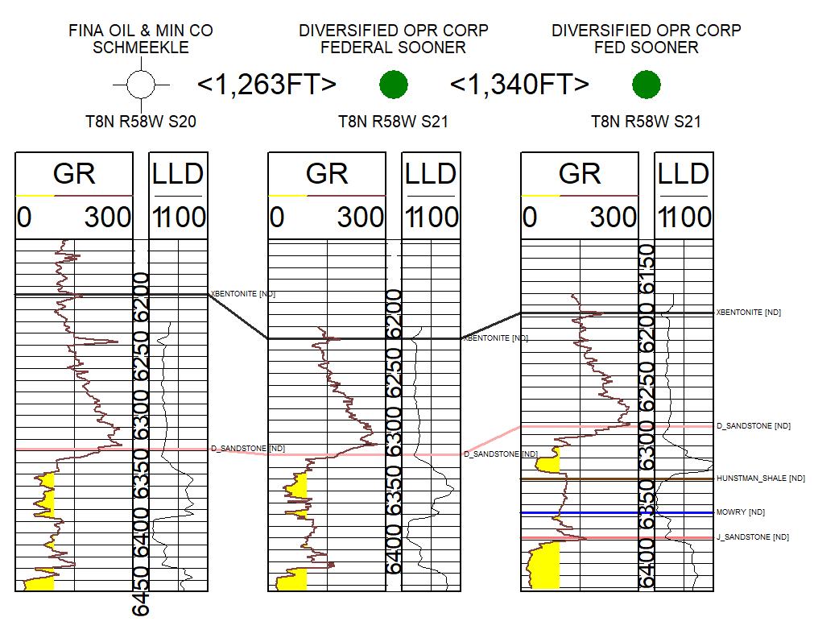
    - LLD
      * SHADE Greater than 15 ohm m then choose colors
      * 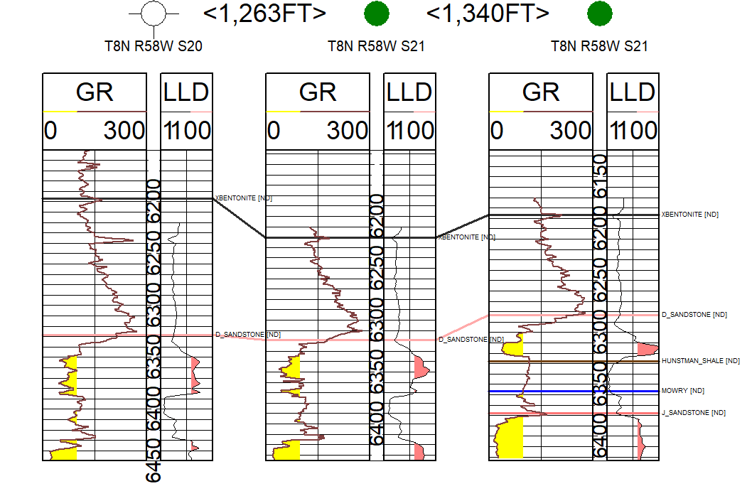
      * Greater than 15 oh m = oil sand stone therefore productive
    - Geo Colum Shaded GR
      * Logs → Display → geo column setting
      * Dont forget to use GR log used for shading
      * 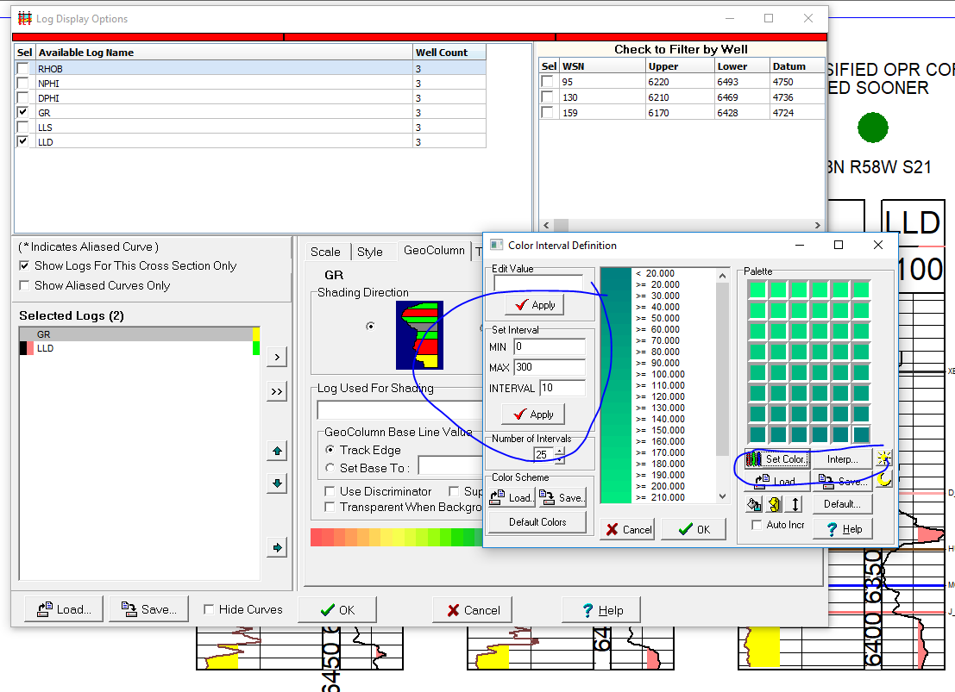
      * Hit apply then okay
  + Add in DPHI_2.65 (CALCULATED FROM RHOB) Into track 3 from log display option
    - 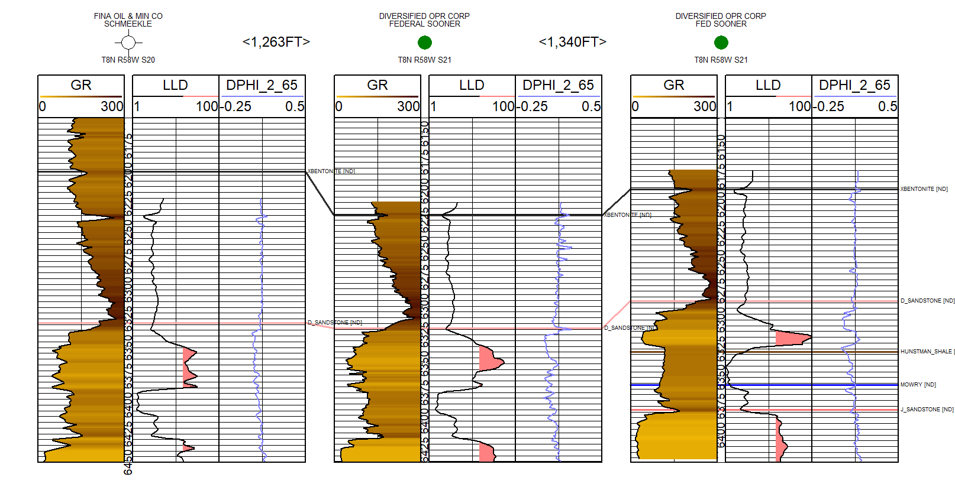
  + Ctrl s → digitial log → log curve → search → click on LLD (We get 30)
    - Go to Z Drive
      * Sooner Data
      * LAS FILES and Sooner other Digits
    - You have GT ILD LLD Resisitivity and RHOB
    - Have tops
    - Keep scales the same 1 - 100 and gama ray 0-300. Density is 2.65
    - **HOMEWORK**
      * Have all logs correlated around 9 sections around section 21
      * To ensure you have all correlated
      * Structure map on top of D, hunstmann, and J Sandstone Maps
      * 3 maps in total
      * Make sure all are picked
      * Were gonna get rid of GP completely
  + Later
    - We will do core digital and core analysis

**2/24/2019 Class**

* In map view:
  + Options → Highlight symbols → wells digits with red round
* Go to logs → aliases → ILD and choose ILD LLD and DIL for aliases
  + Now all have astrid for ILD aliases
  + 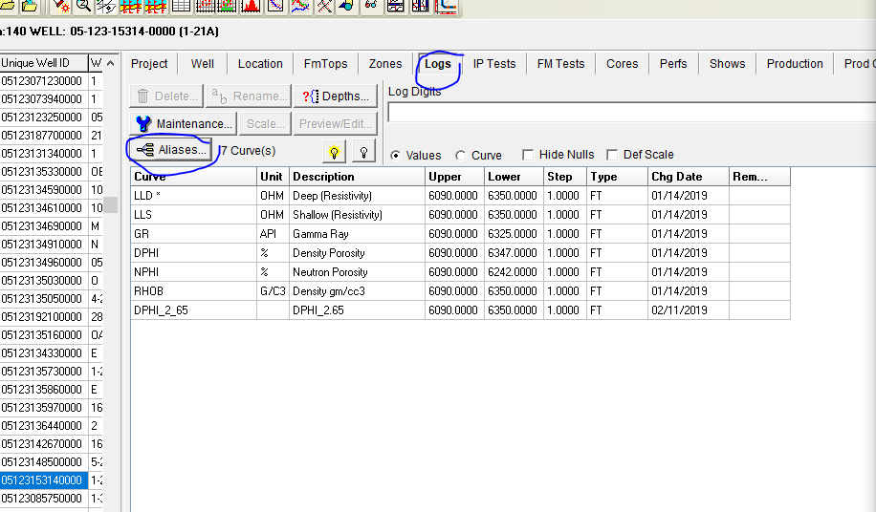
* Make Isopach Map
  + 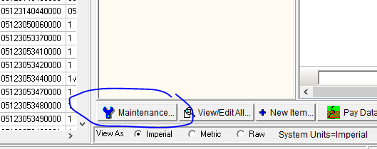
  + 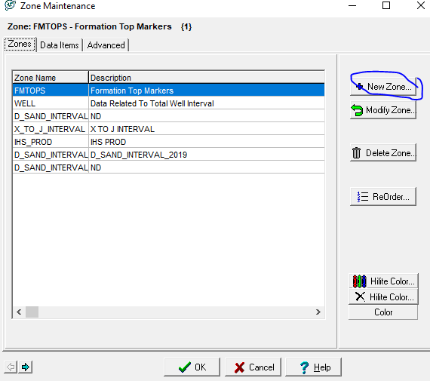
  + Make new zone with correct top and bottom formation tops
  + Compute → From Zones → Isopach Maps
  + 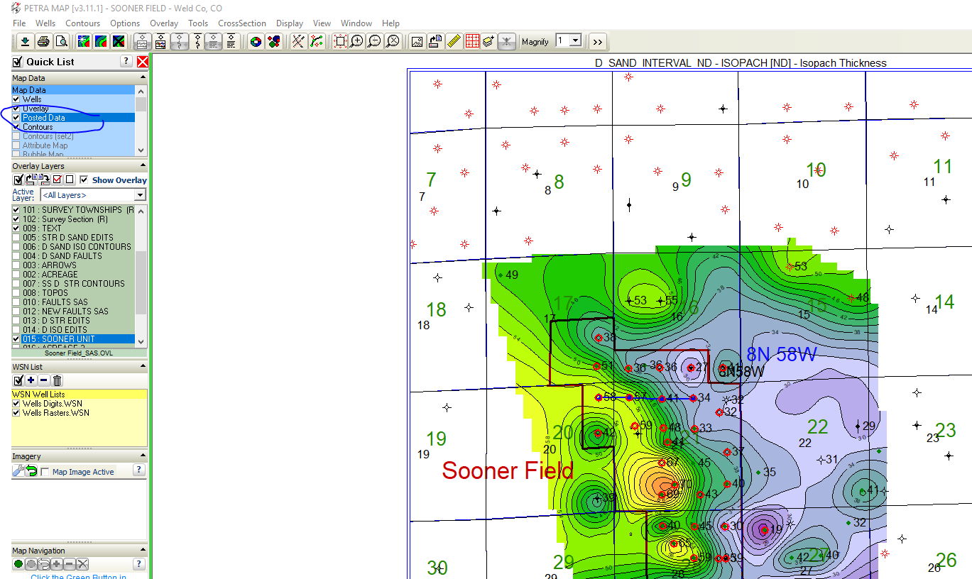
  + Double click on posted data → Show isopach map
  + Then contour make grid → make isopach map
  + 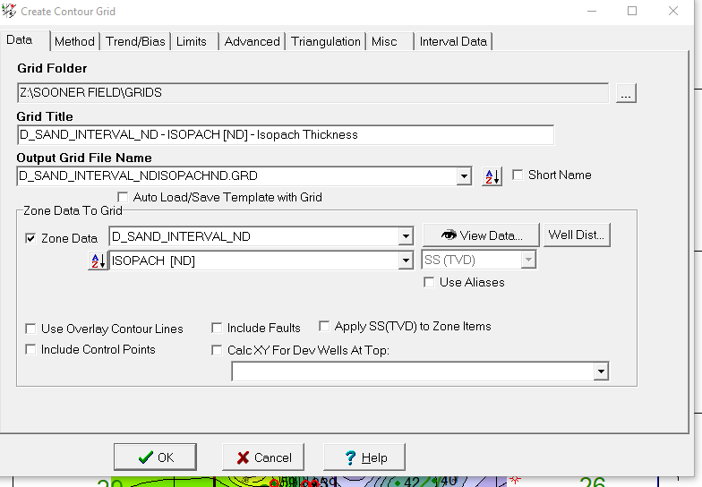
  + Contours → display contours → every other countour bold
  + 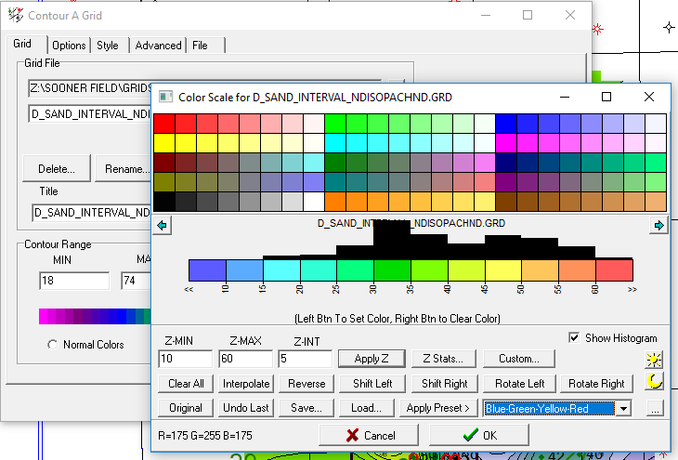
  + 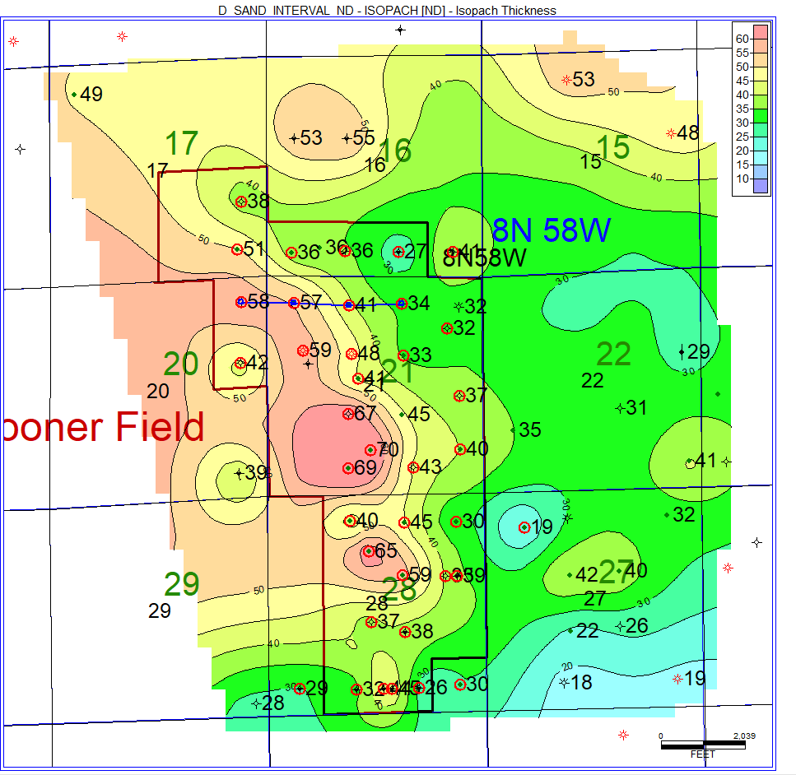
  + Contours → create grid → method (estimate to smaller) to honor the data
* Notice ^ it is a “Valley Filled Sandstone trending north west to south east” Updipping to the east
* Scout tab
  + COMPUTE → fRom task → Production Test data
  + 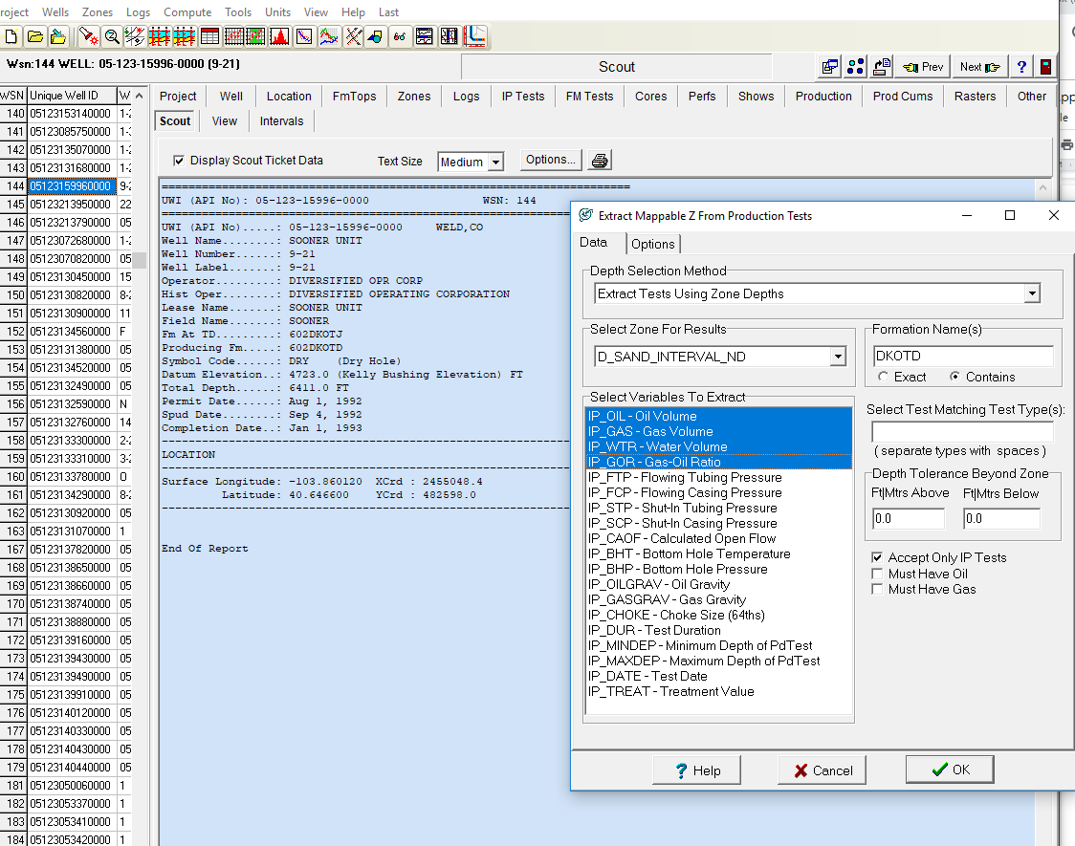
  + Now we have
  + 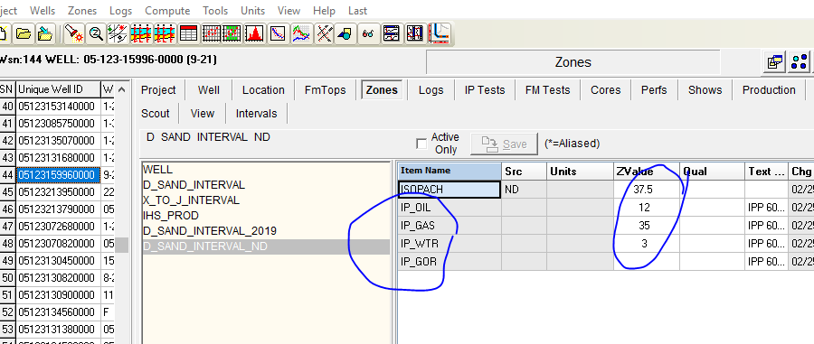
  + Bubble map
    - D-sand-interval_nd
    - IP_OIL
    - Display radius bubbles
    - 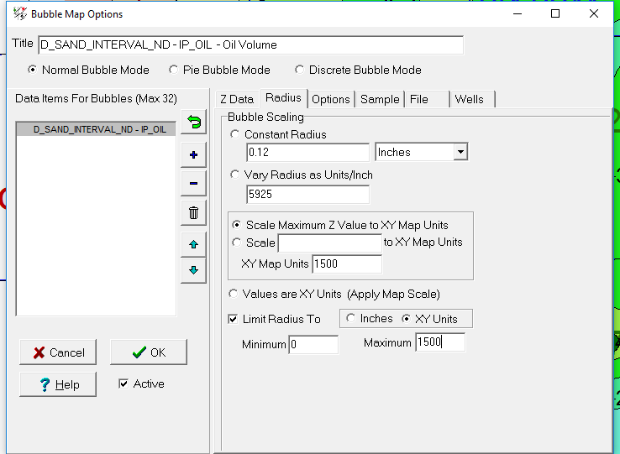
    - 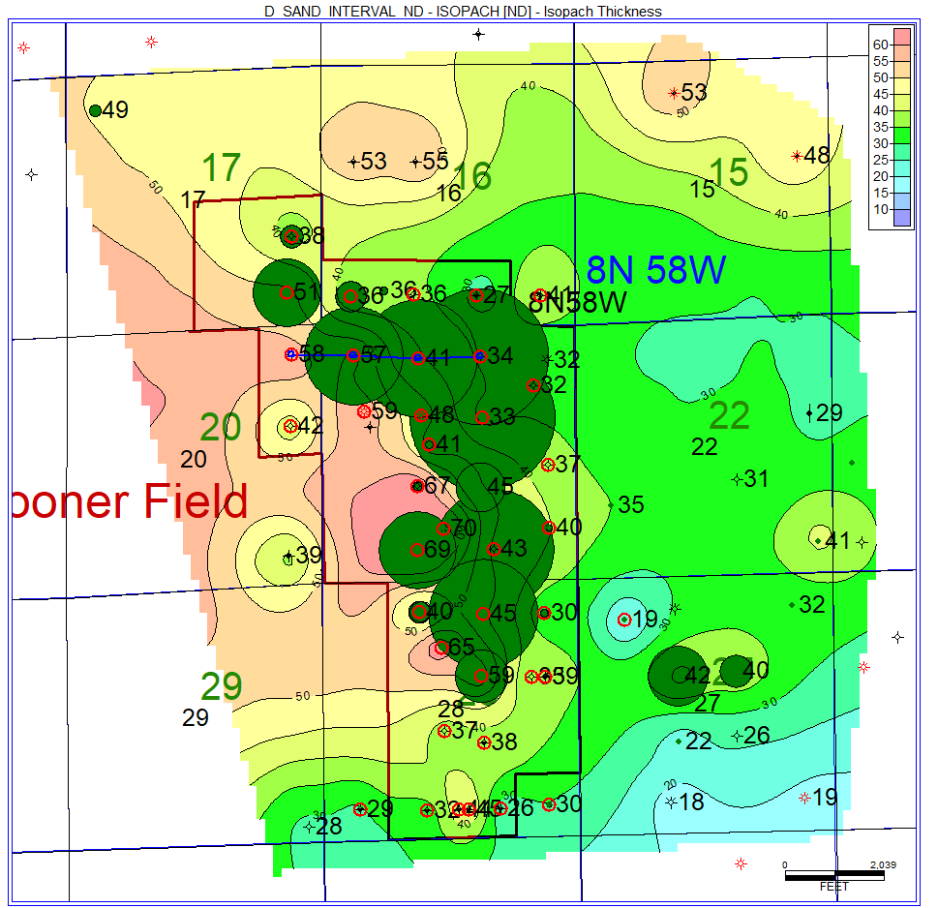
  + Make Structure on top of D
    - Contours → 2nd contour set
    - 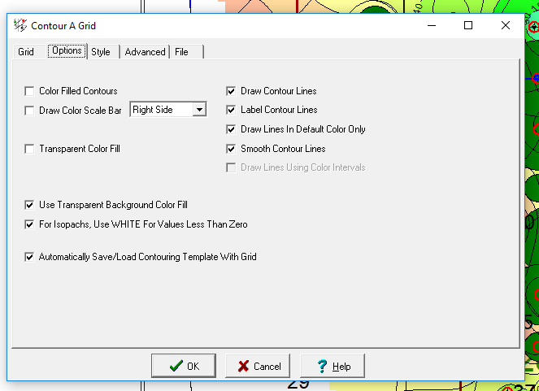
    - 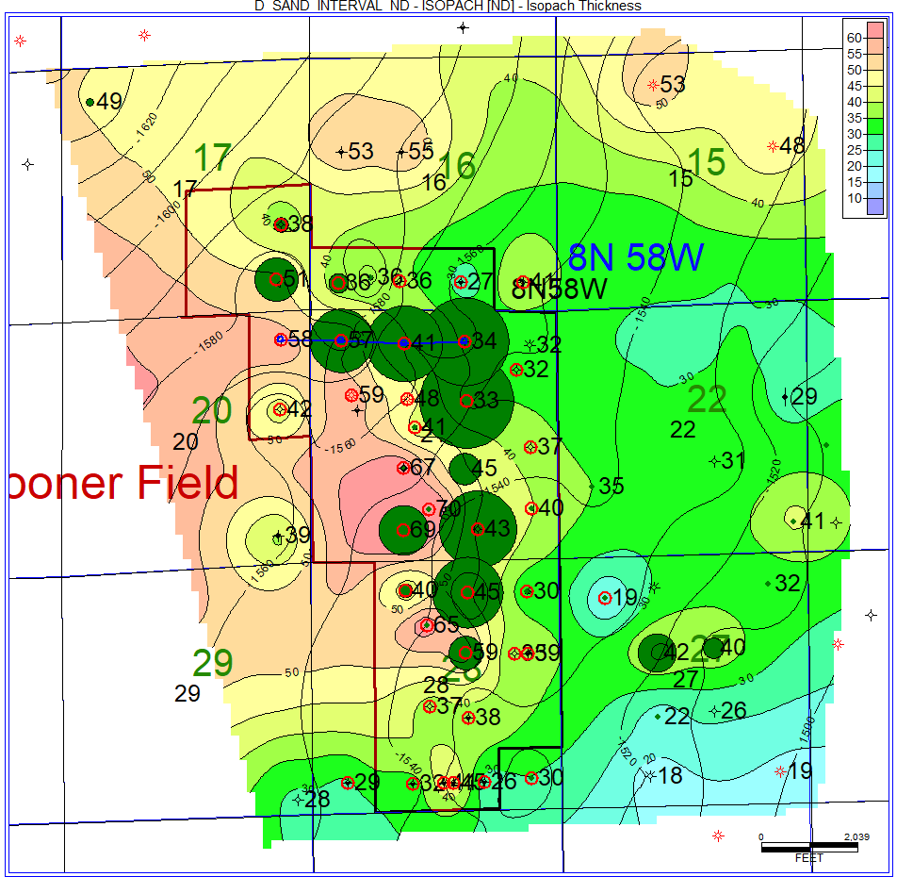
* Compute → Logs → Log Equation Transform --> load archies SW
  + Options → selected wells → next
    - Output log “SW_2_65”
    - Assign the values for all
    - 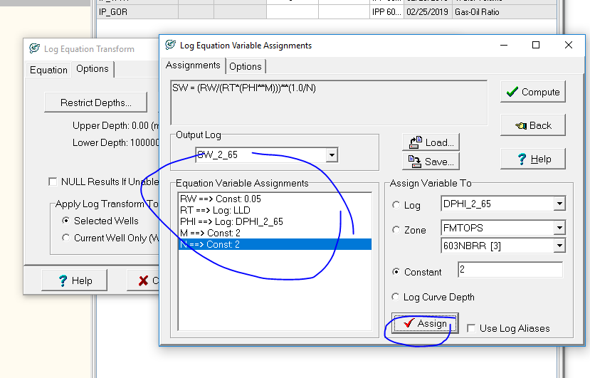
    - tHEN save as SW_2_65 in parms folder
    - Then compute
  + Now in the logs you have DPHI_2_65 and SW_2_65 with values
* Save Digital Log Template with SW on Track 4
  + 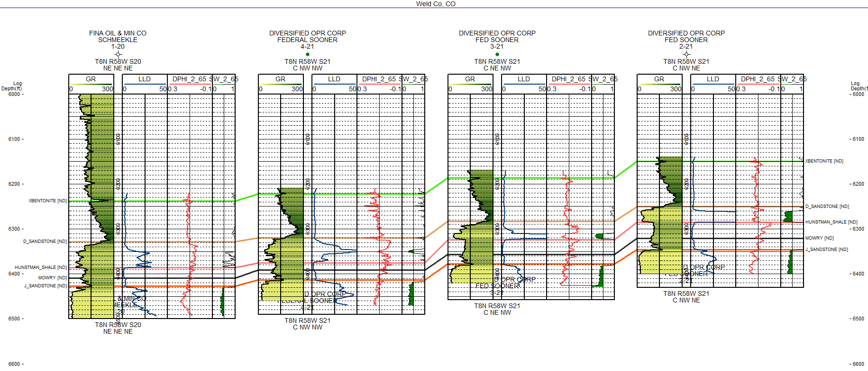
* Log Cross Plot symbol
  + Depths, set depths, ss interval nd
  + 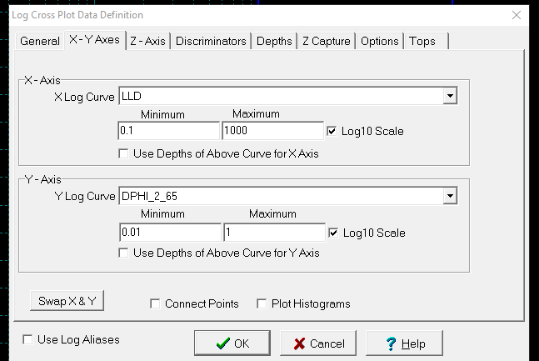
  + Wells, select by data criteria, logs, digits, 38 wells
  + Now you have
  + 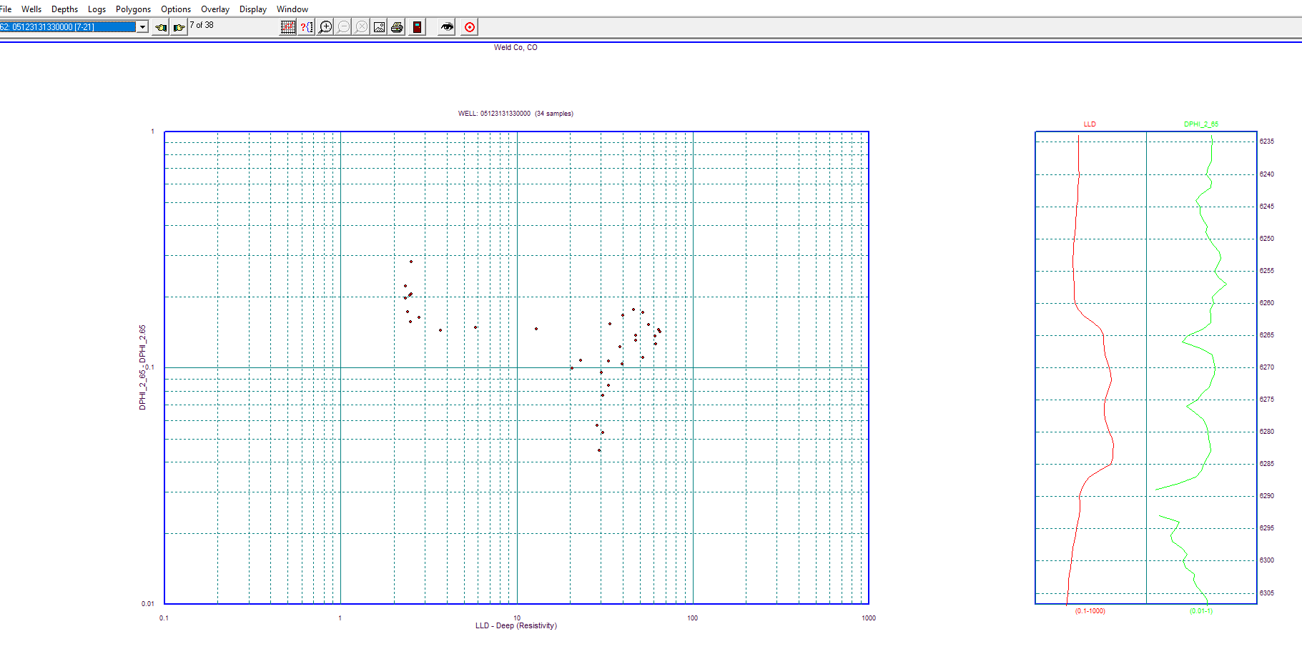
  + Options → picket plot
    - Set values to:
    - 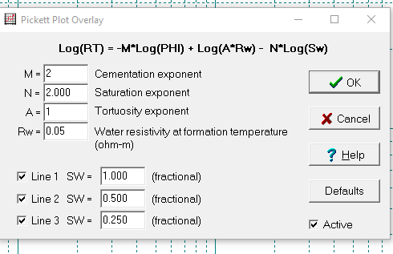
    - 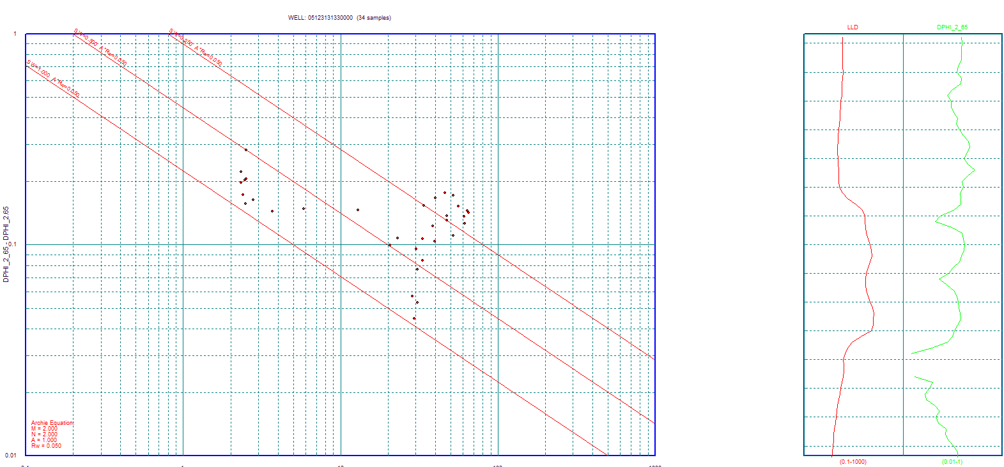
  + Polygonds → add
    - Make 2 polygons
    - 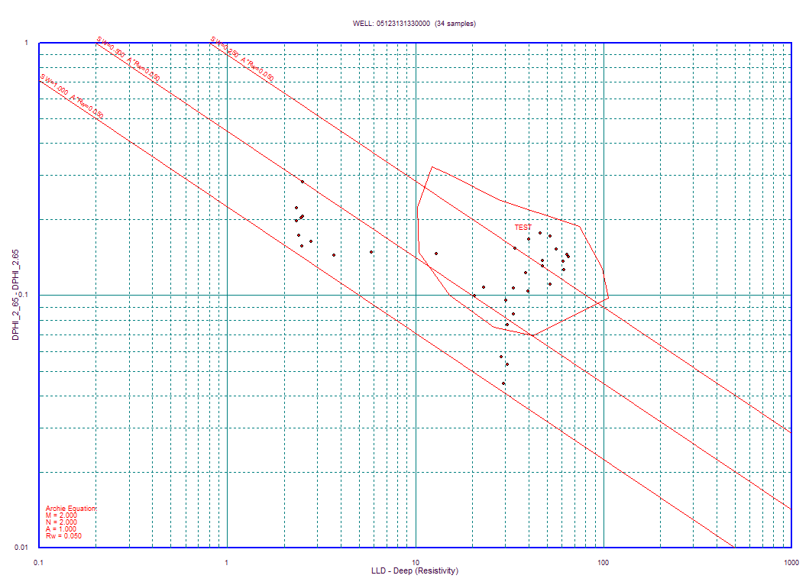
    - 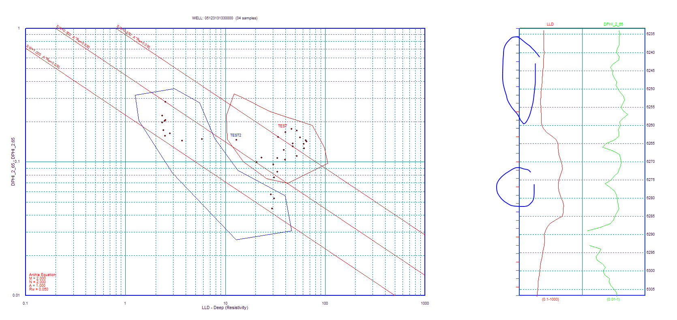
    - **Logs →** hilite by depth
    - 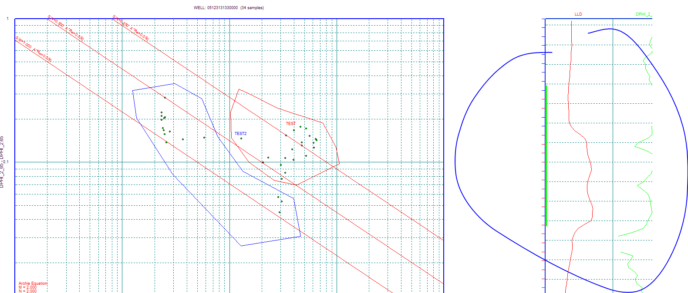
  + Hilite the high resistivity
    - 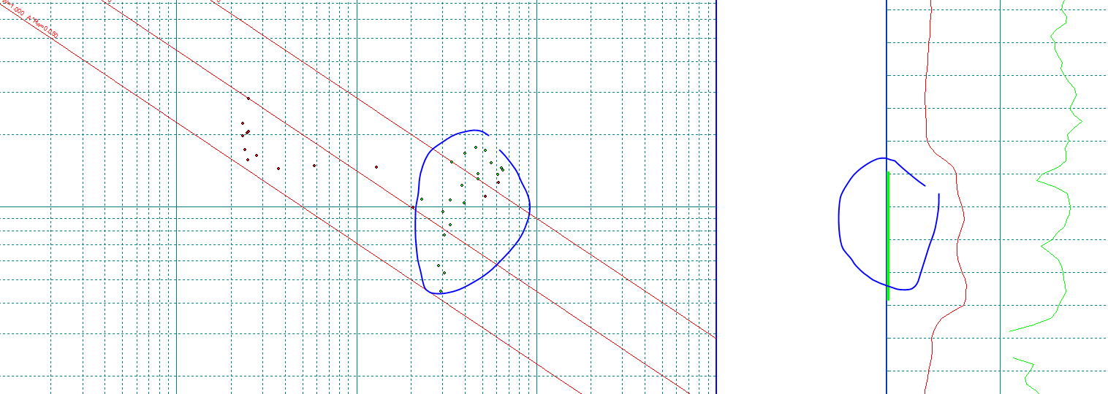
* Options , chart book overlay, buckles
  + Depths , set depths
  + 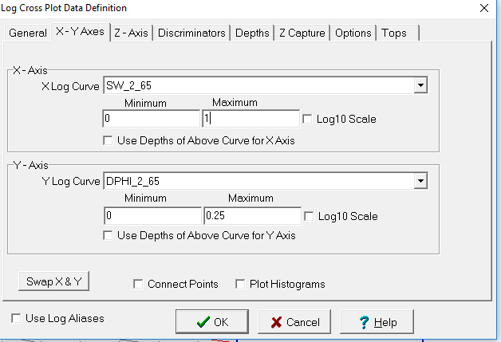
  + Now we have
  + 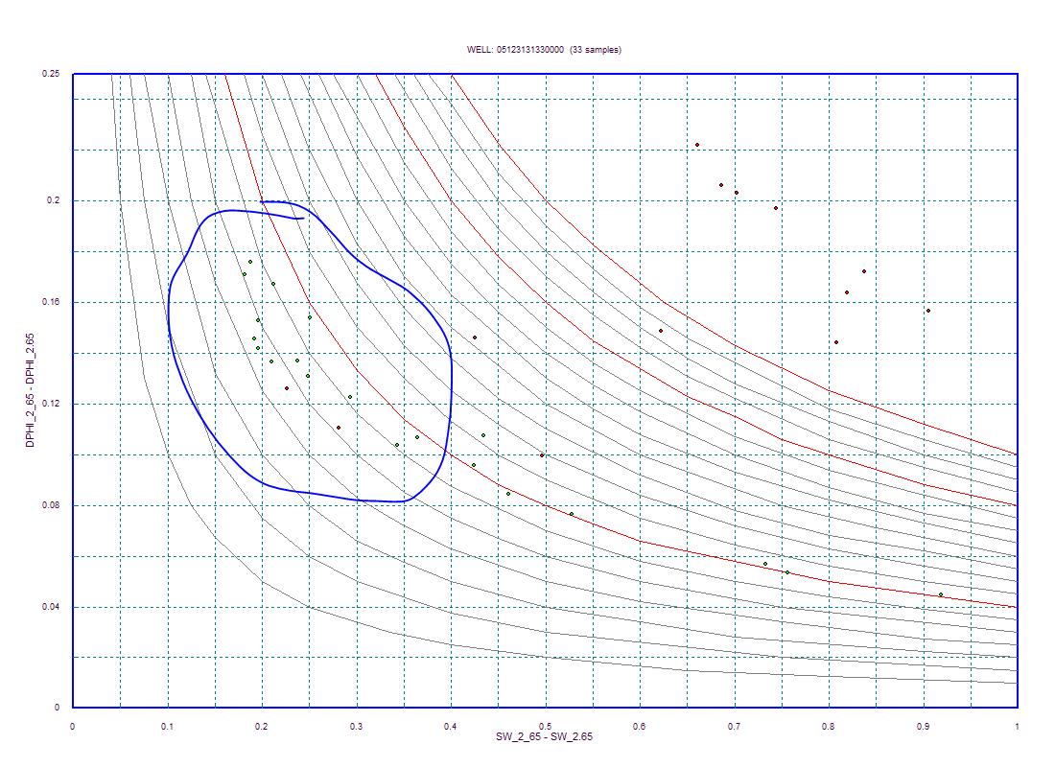
  + ^ improve reservoir quality as we move to the bottom left direction,
    - Going to lower water saturation. Right up in the points
    - One of the Buckles plot!!! Important in reservoir characterization
  + Options, chart book overlay
    - There are more than just buckels - may want to use CNL RHOB, or SWIPHI etc
* Go to main module
  + Select well 62
  + Compute → RW from SP Calculator
  + 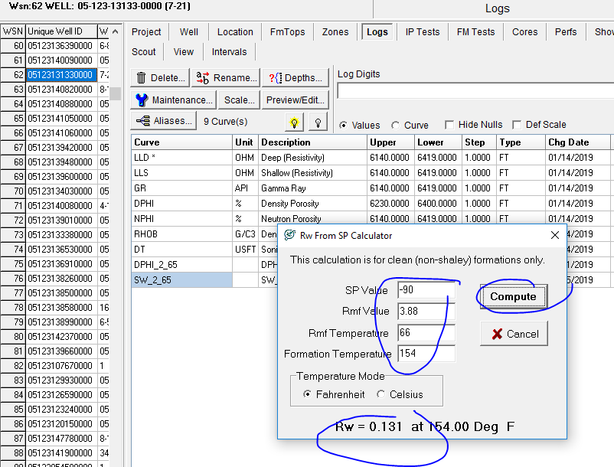
  + RW is resistivity of formation water
* Compute, from logs, equation formation
  + 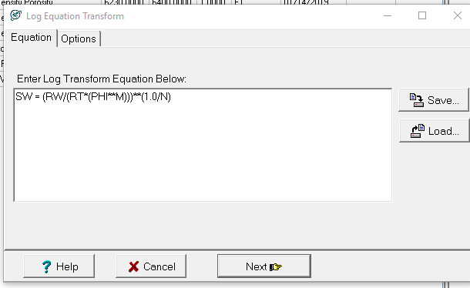
  + **CLASS NOTES**:
    - Sw = n root sqrt(R0 / Rt)

= n root sqrt( ( 1 * Rw ) / (phi^2 * Rt))

* + - Ro = F Rw
    - F = (1 (a) ) / (phi^(m=2))

So, if you do a log log plot, of resistivity, we can solve this real quick! In pickett plot!! Pickett used to go to Mines

* **HOMEWORK**
  + Make bigger picks! Making full of the sections
  + 1 Structure Map DSS
  + 4 Isopachs
    - Isopach DSS
    - Isopach Graneros (X bentonite) to Dss
    - Isopach Huntsman to Graneros
    - Isopach Graneros to Mowry
  + 2 Cross section NS and EW
* Open Z folder, Sooner Data, Sooner 7-21 core data spreadsheet
  + Project, import, digital log, tabular ascii file
  + 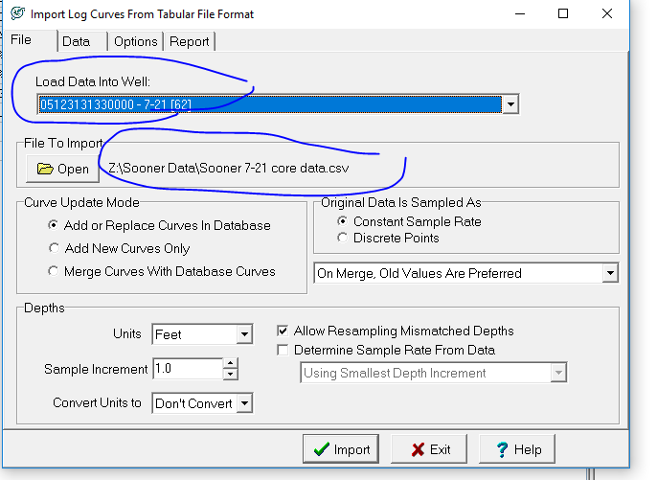
  + Click data on second tab, then bring in
  + 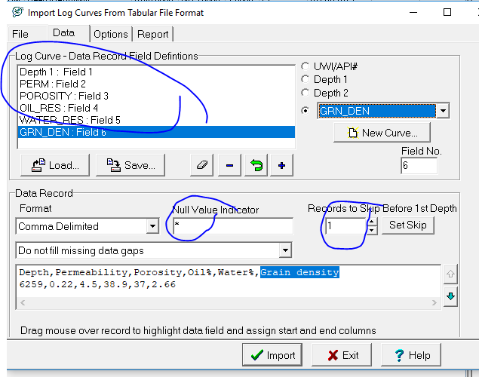
  + Now in main menu youll get
  + 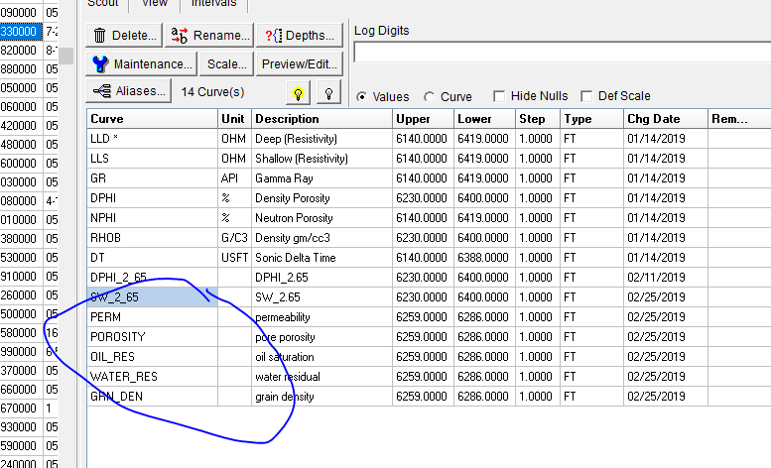
* Now add Porosity into the cross section
  + 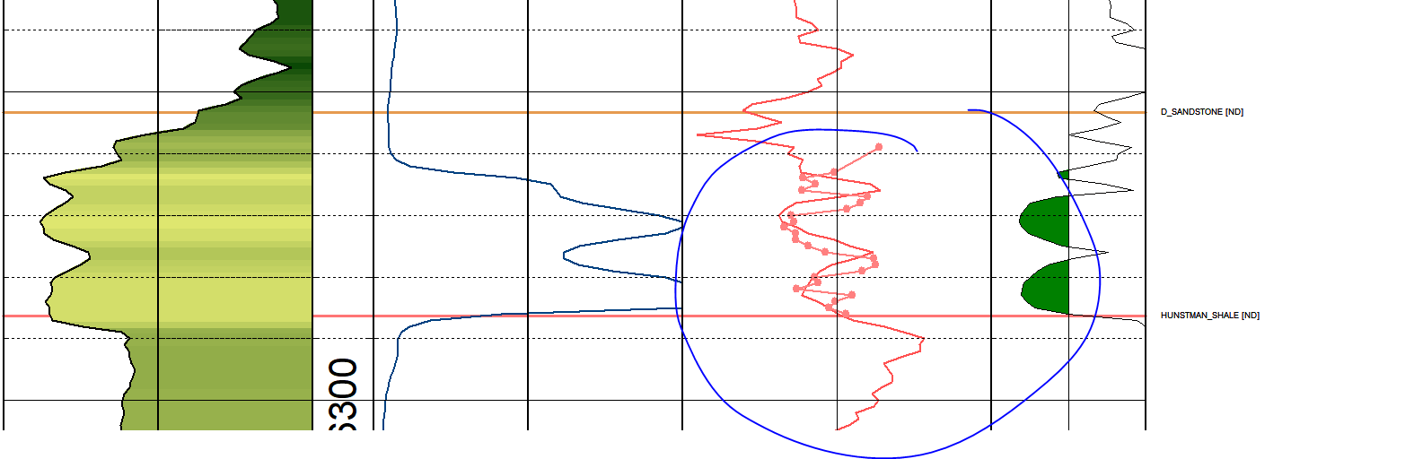
  + Now, main menu to shift the depth together
    - Log, depth shifts
  + Now logs, display, Porosity_S
    - 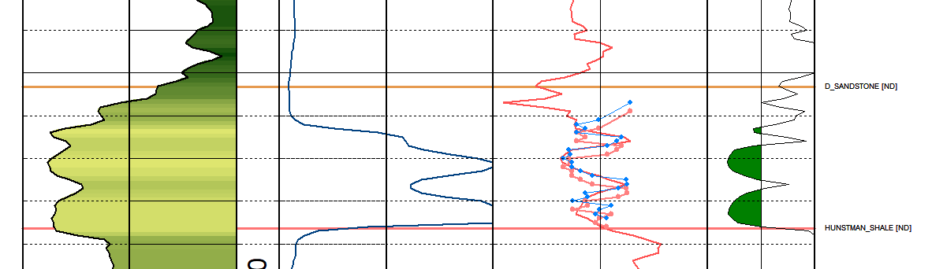
    - The blue one is the shifted porosity, the red is original
  + Change the shifted porosity to red.. Now we get:
  + 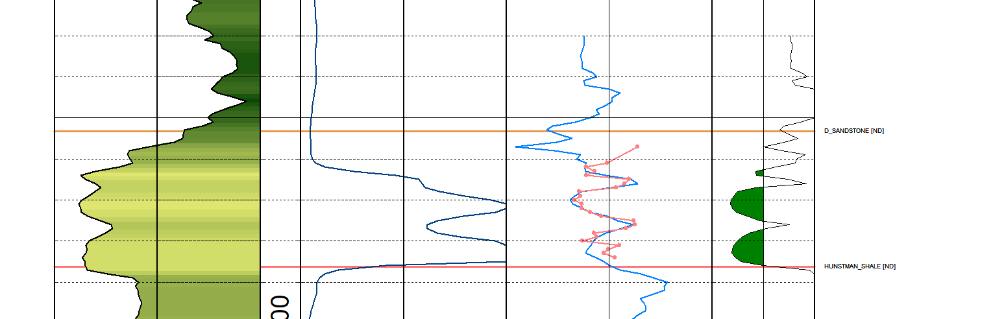
  + ^ So these are Core Analysis, and it looks good
  + The template is saved
* Wells, Plot test indicators
  + 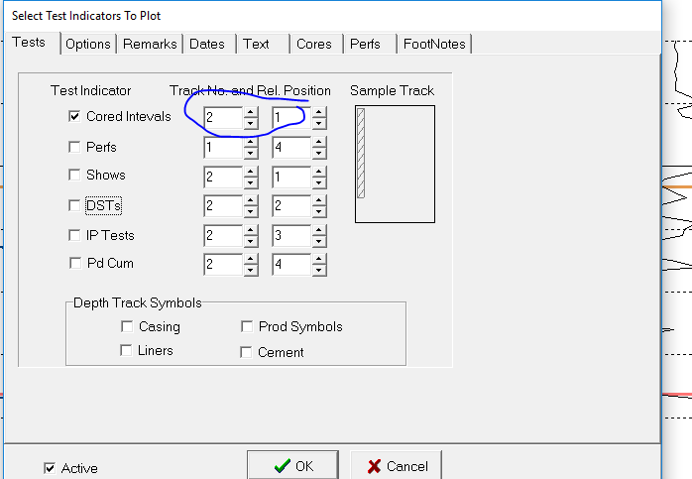
  + To change colors go to main menu
    - Projects,settings,system colors,xsection cores
    - 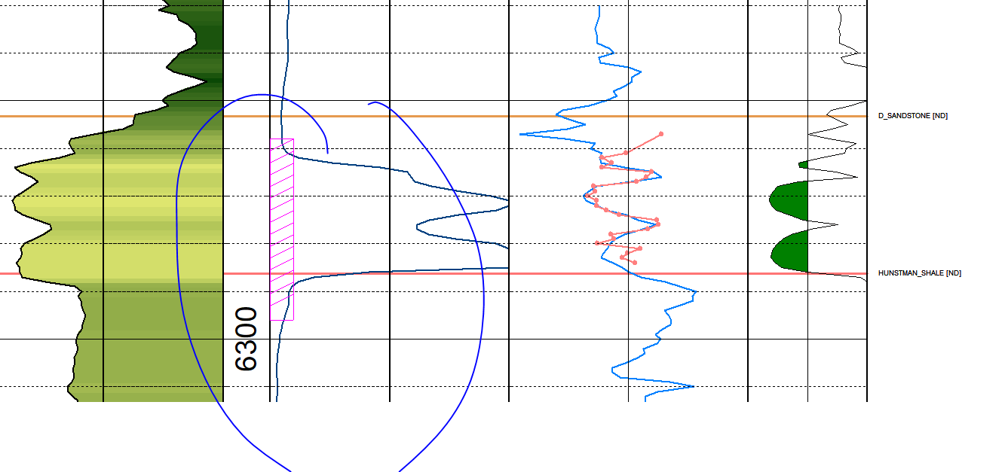
* We get Core Description Handout
  + Main menu, intervals, lith, edit details
  + 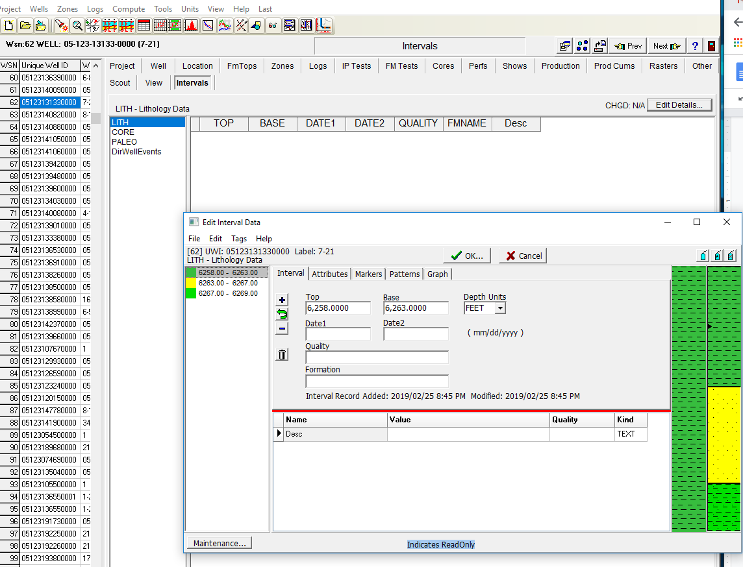
  + **HOMEWORK:** Add 10 more!! Top to bottom

**3/4/2019**

* Digitize logs
  + Go to start menu
  + Double click on induction log 5 in
    - Click on Curve
    - ILD, Logrithimic scale, .2 to 1000
    - Start and stop
    - Save as image folder
    - Store
  + Double click on density 5in
    - 0 - 200 non log for GR
    - Then start and stop
    - Right arrow for next interval
    - Save and store
  + RHOB
    - 2-3
    - Save and store
* Now calculate DPHI 2_65 and SW 2_65
  + Compute
  + From logs
  + Equations and expressions
    - Load Density, next
    - Load the DPHI 2_65, then compute, then dhi265 log should pop up in main menu
  + Compute, fomr logs, equations and expression
    - Load water saturation from archie, next
    - Load the SW 2_65 in parms folder, the ncompute, then SW 2_65 log should pop up in main menu
* **HOMEWORK**
  + Do the rest of the raster log → digitize
* Residual Mapping
  + Contours , create contour grid, third tab trend/bias click second button
    - Rename with trend
    - Now we can see the trend going from shallow to deep
    - 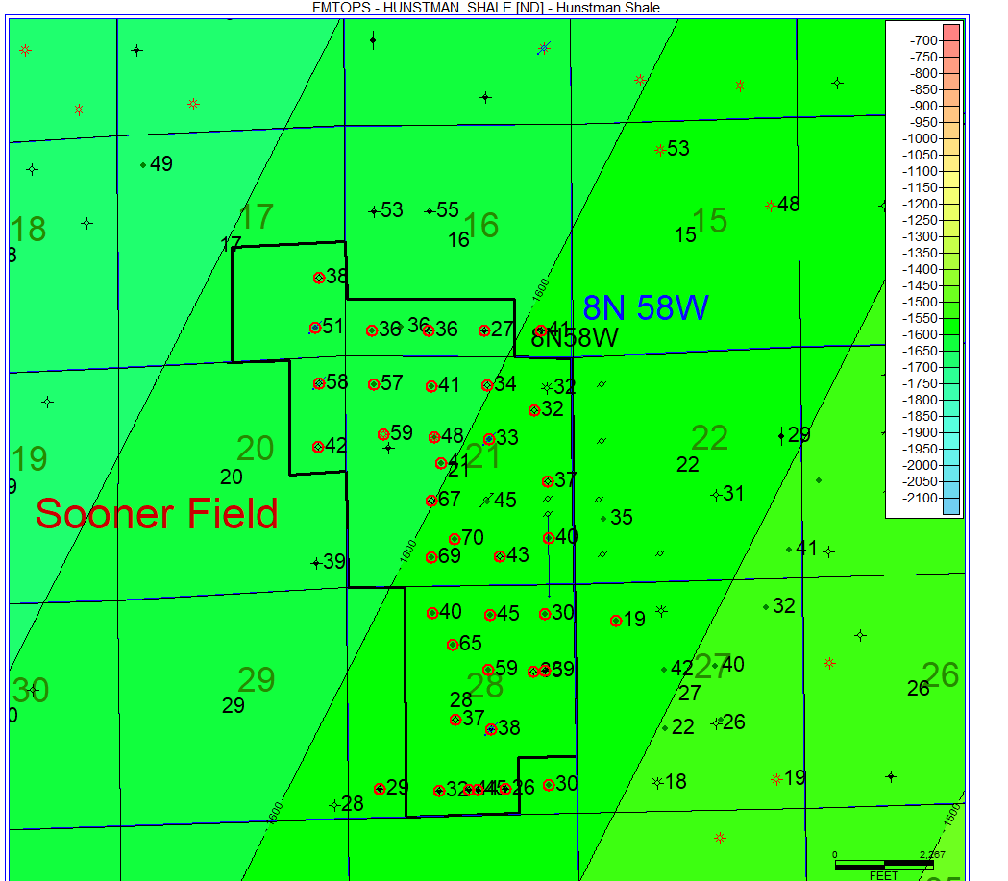
  + Contours, create grid, three tabs click on third button for first order
    - Rename first order residual
    - Now it accentuates the topographic low area in a big way, theres a big low on the north west
    - 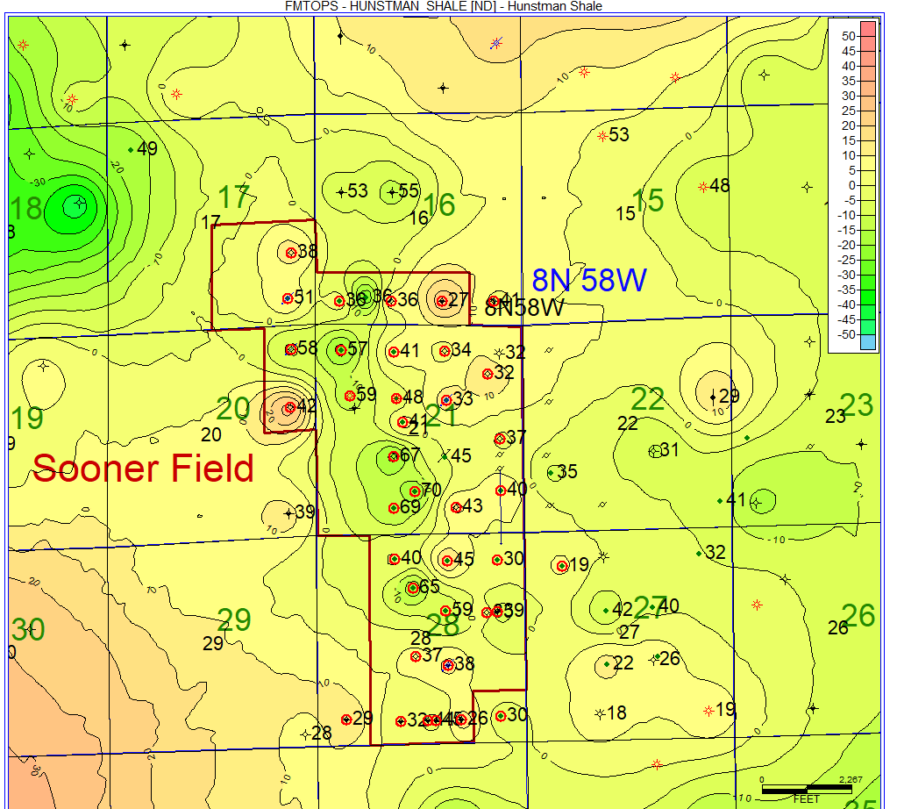
  + Contours, same…
    - Second order residual
    - 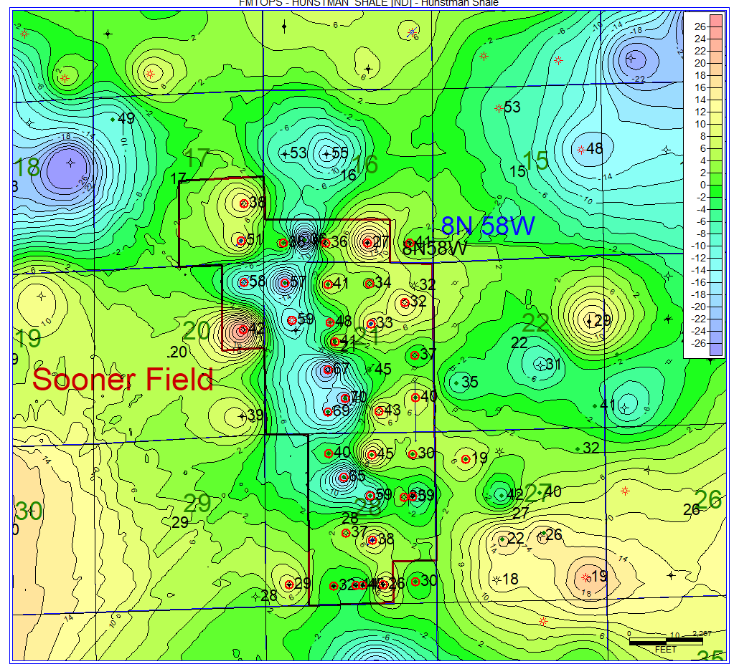
  + Compare to original structure map of hunstman
    - 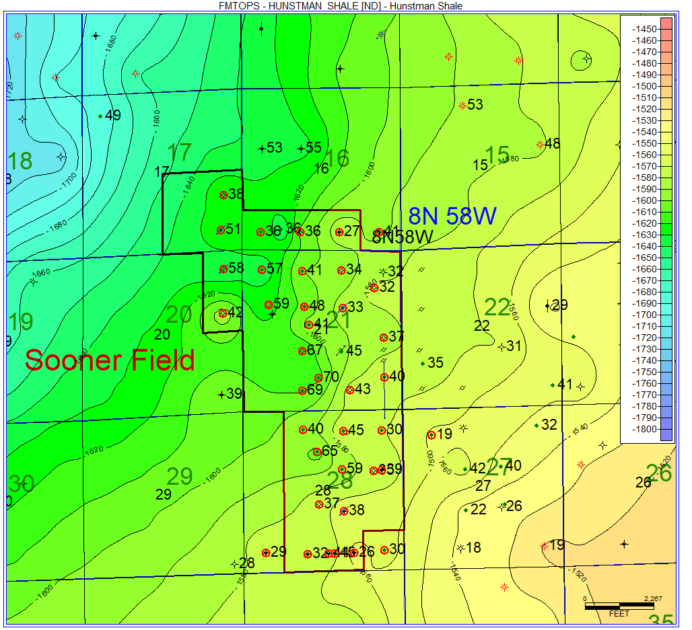
* LOG R
  + **HOMEWORK** → Read paper from Hoods and Passey
    - Read passey method paper to understand log r and toc density
    - Why
      * Rbase = 1.5
      * Rhobase = 2.5
  + LOG R(DEN)=LOG10(R/RBASE)-2.5*(RHOB-RHOBBASE)
    - Rbase = 1.5
    - RHObase=2.5
  + TOC Density
    - TOC PASSEY DEN=(LOGR)*10**(2.297-(0.1688*LOM))
* Other noted equations
  + Youngs Modulus
    - YM=10000*RHO*(1/DTS)**2*(((3*(1/DTC)**2-4*(1/DTS)**2)/((1/DTC)**2-(1/DTS)**2)))

* + Poissons Ratio
    - PR=(1/2*(DTS/DTC)**2-1)/((DTS/DTC)**2-1)
  + Brittleness
    - BRITTLENESS=YM/PR
* Now for Well 62, calculate log r
  + Equation, from logs, equation from expression load log r
  + 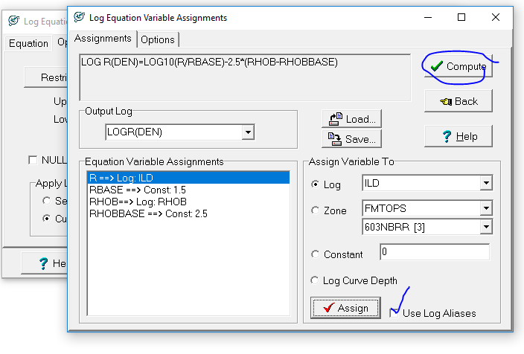
* TOC DENSITY
  + Equation, from logs, equation from expression load TOC PASSEY
  + 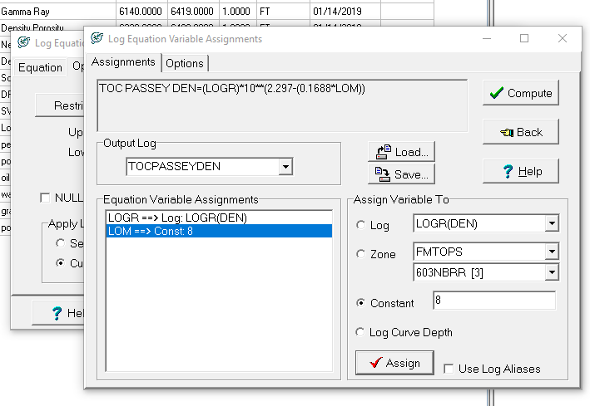

Plot the Core Log with colors

* Wells, Plot interval data, track 0
* 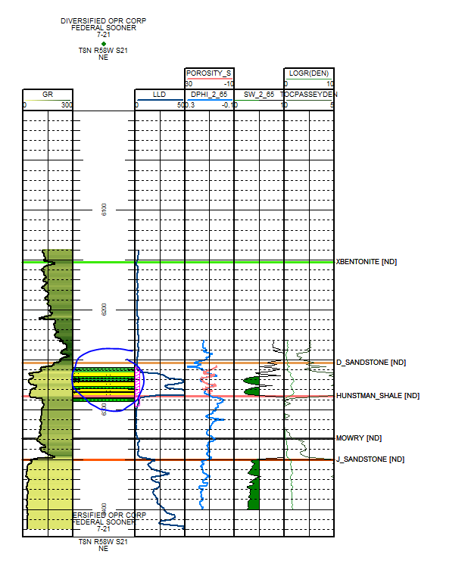
* Compute, from logs, footages
  + 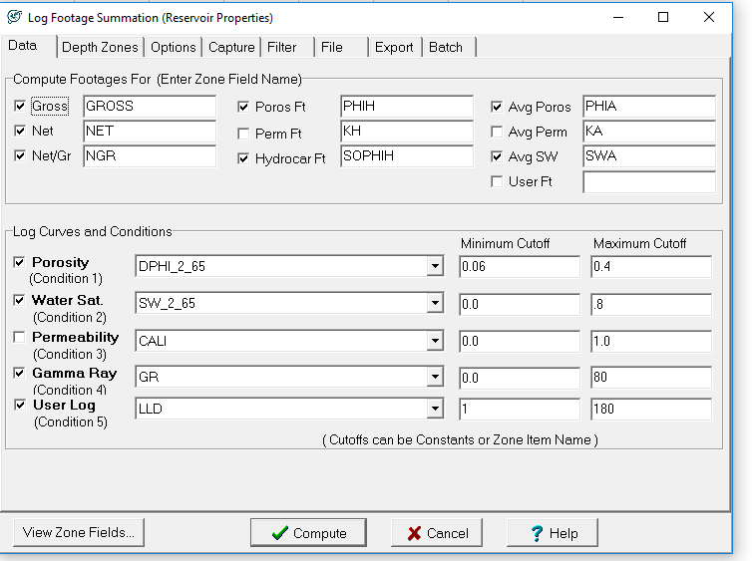
  + 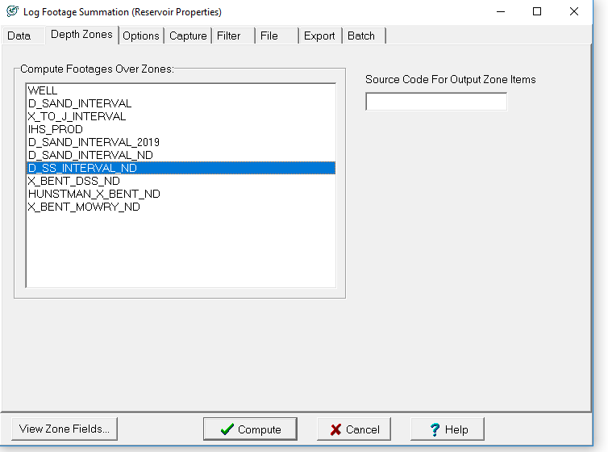
  + 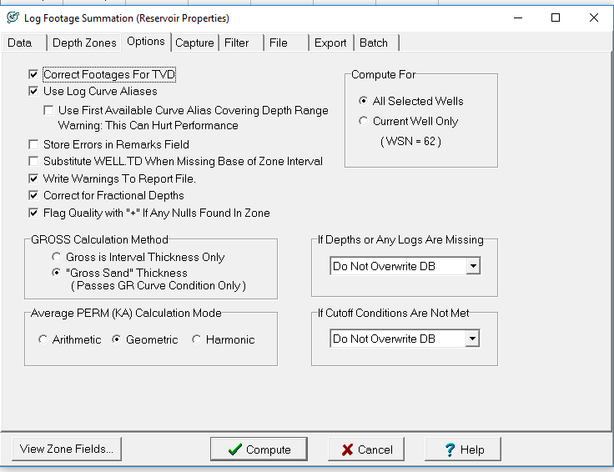
  + Now we have these
  + 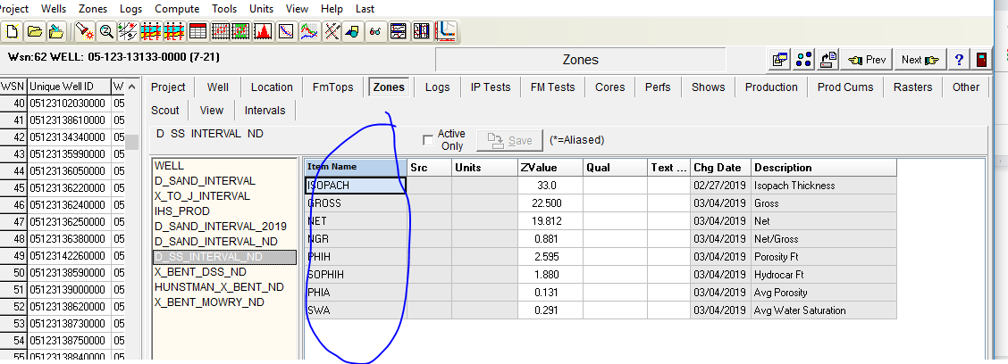

Now map these

* Create contour grid
* ND SS interval, then SOPHIH, no trend residual
* 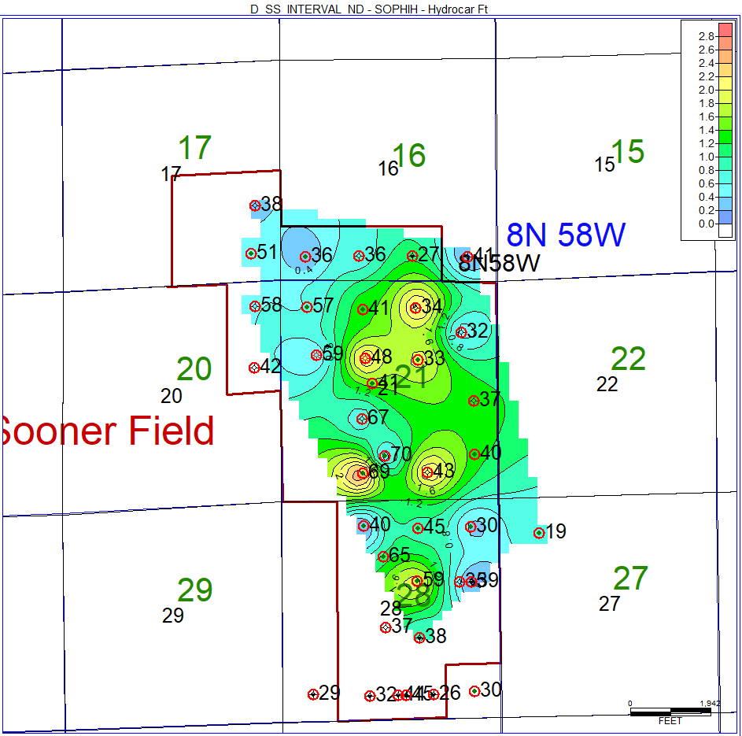
* Volumetrics,
  + Compute volume from grid
  + Data is ndsophih
  + 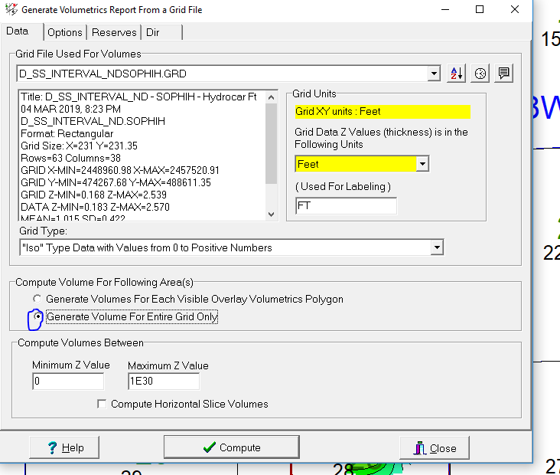
  + 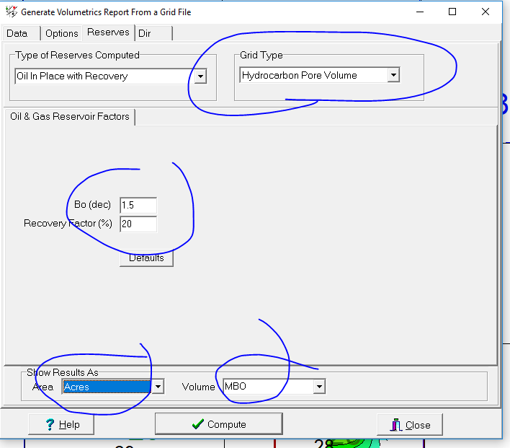
  + Then compute
  + Our result is
  + 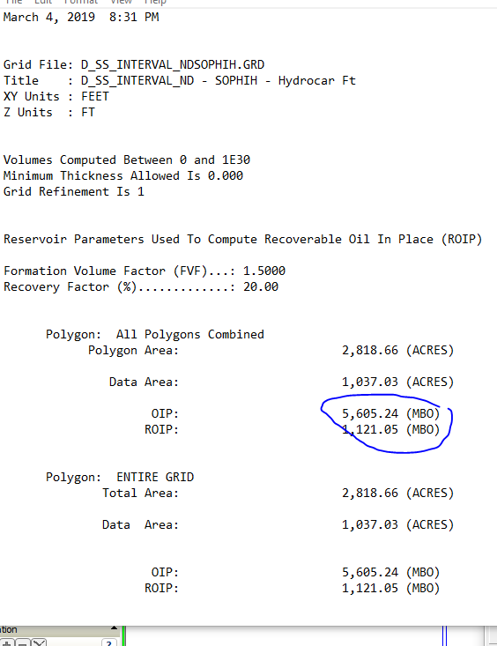

**3/11/2019**

Kingdom Software

* Click first license, and make project
* N America, US, US State Plane nad27, Colorado north
* Survey, survey management, New Survey Name(Sooner 1)
* 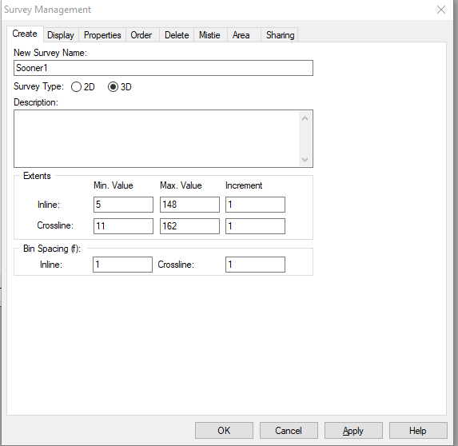
* Click yes, then type

5.00 11.00 2444543.00 473643.00

5.00 162.00 2444330.00 488741.00

148.00 162.00 2458629.00 488943.00

* + Click next then finish
* Bring Data In: Survey import seg y, first one, all 32 bit, etc etc…
  + 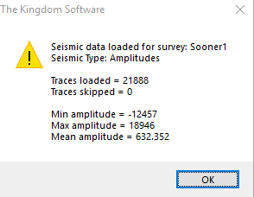
* Right click on cross line.. Display crossline 121
* Culture, import, culture layer, lay 1000 under soonser seismic culture data
* Culture, culture management, lay 1000, red, 4 line, apply

**HOMEWORK:** Get more space on z drive! And move from c drive to save to z drive

* Import wells
* Double click on the mapped 1-28 corner right bottom well,, and activate the well A button
* Show up the wells in the seismic line, clicking on the top left button
  + 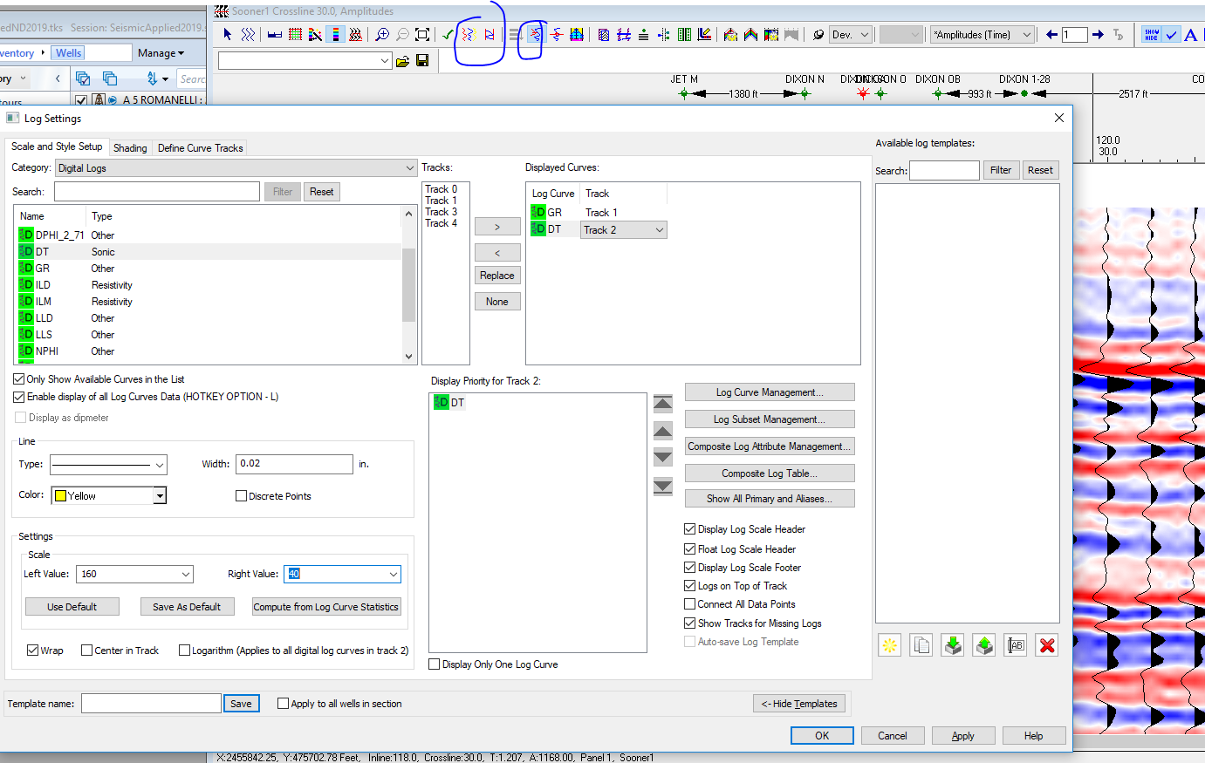
* 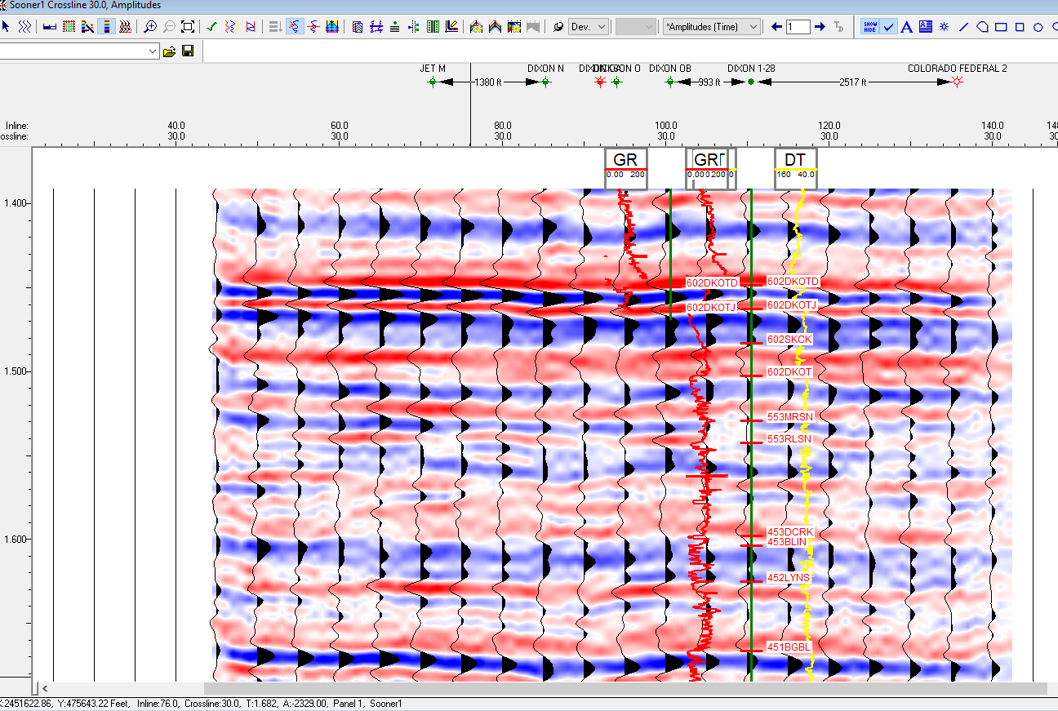
* Make sure its activated
* 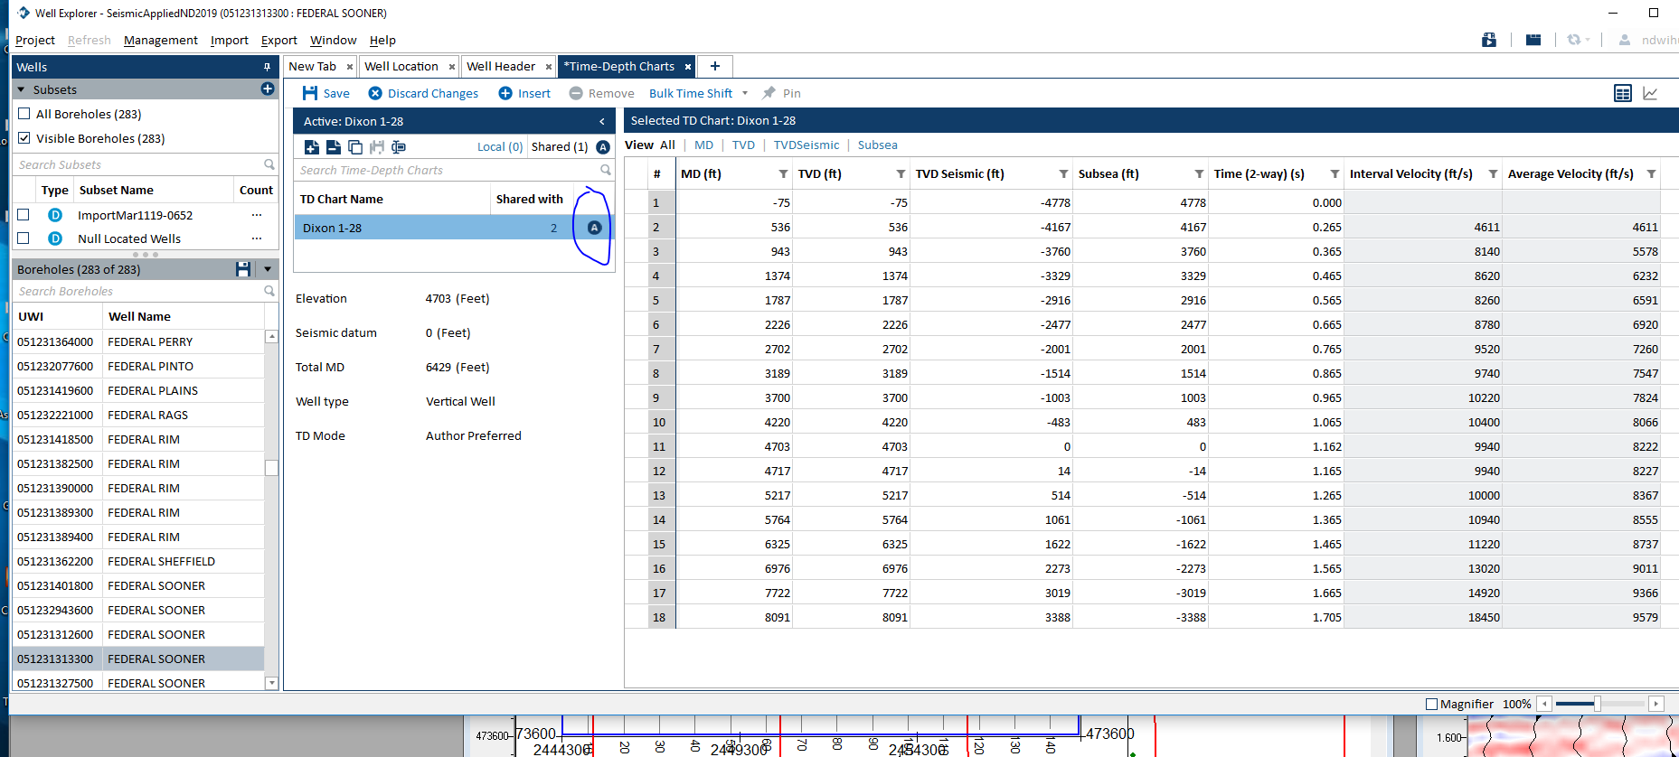
* View, toolbars,
  + 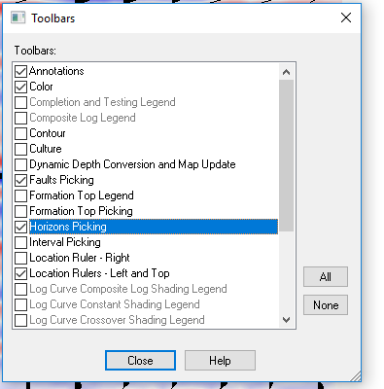
* Horizons, management, red, d sandstone...now choose a peak.. Since shale on top ss below, positive amplitude anomali
  + 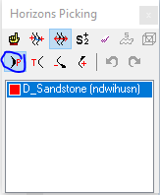
  + Then just click on the interval
* D Hunt Picking
  + 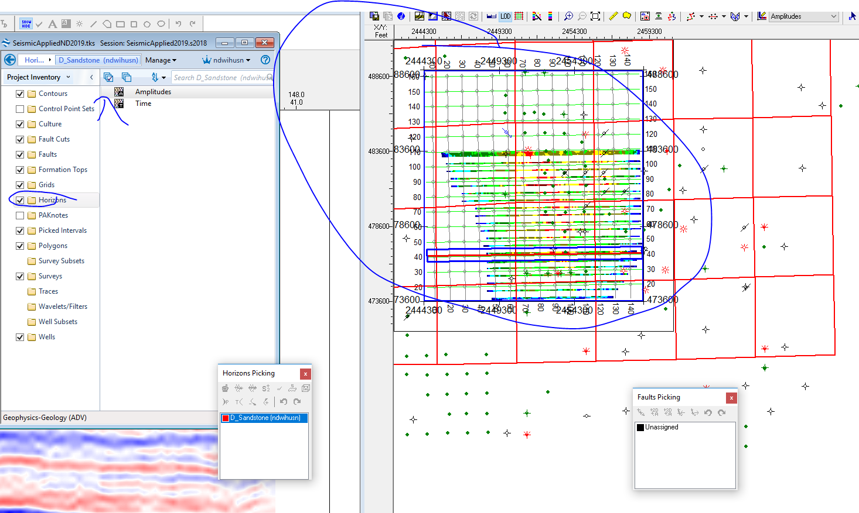
* Keep picking all
  + For D SS make sure its in the right scales
  + 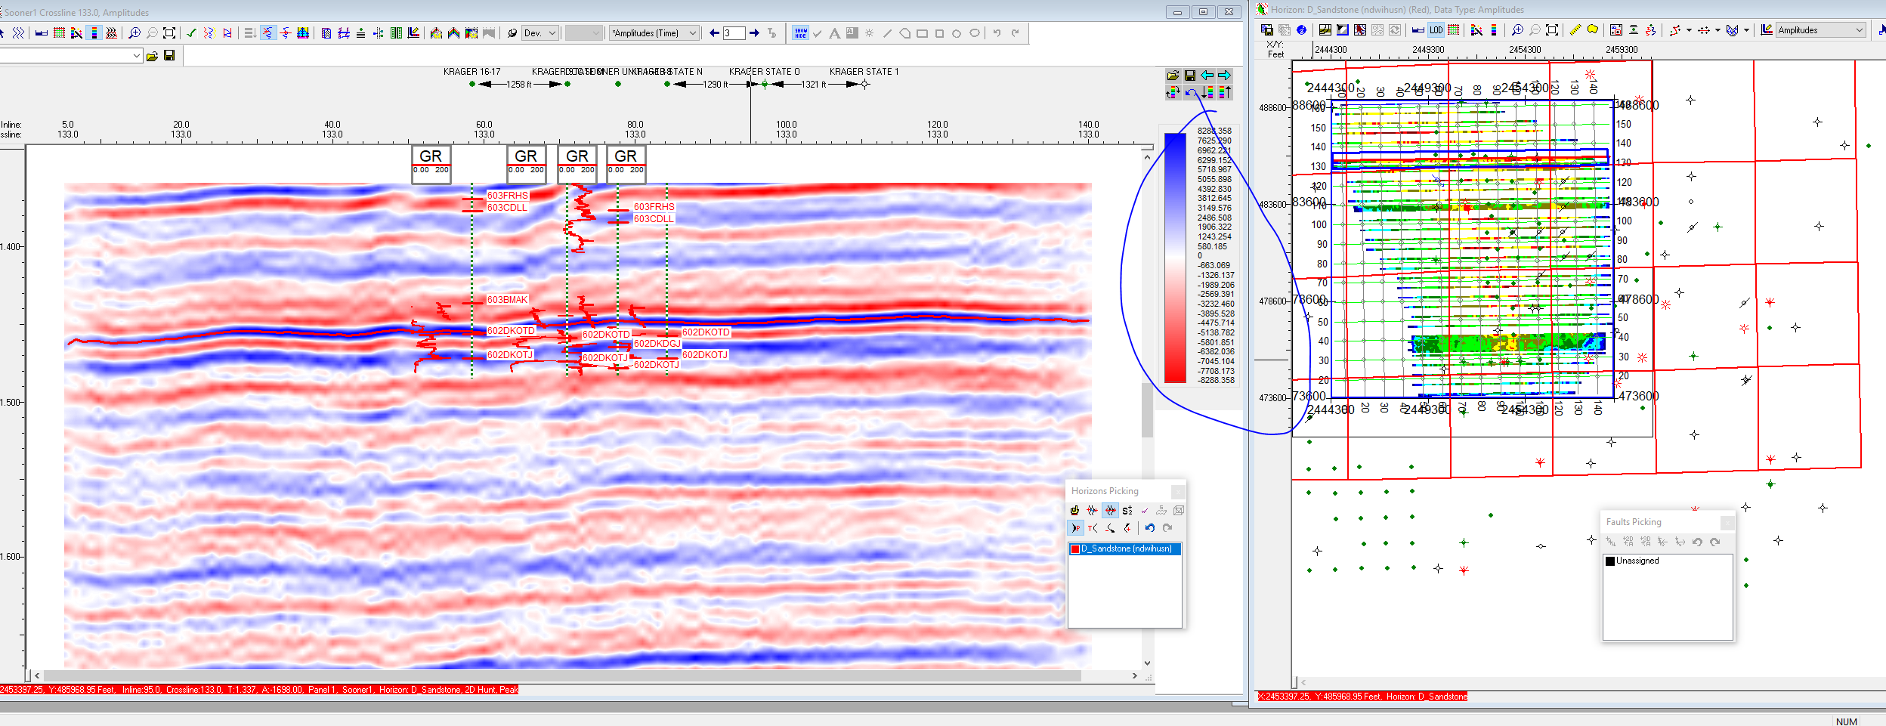
* Now do the Inline and crossline
  + 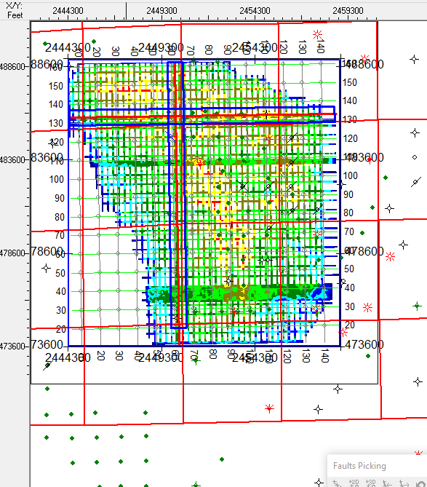
* Right click, 2d hunt ^^^ previous steps
* Now, right click on seismic, 3d hunt then amplitude, then ok
  + 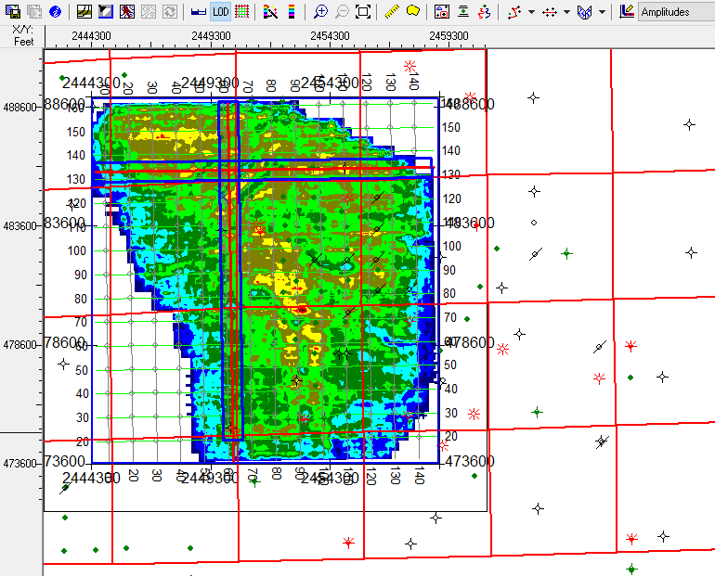
* Change color
  + 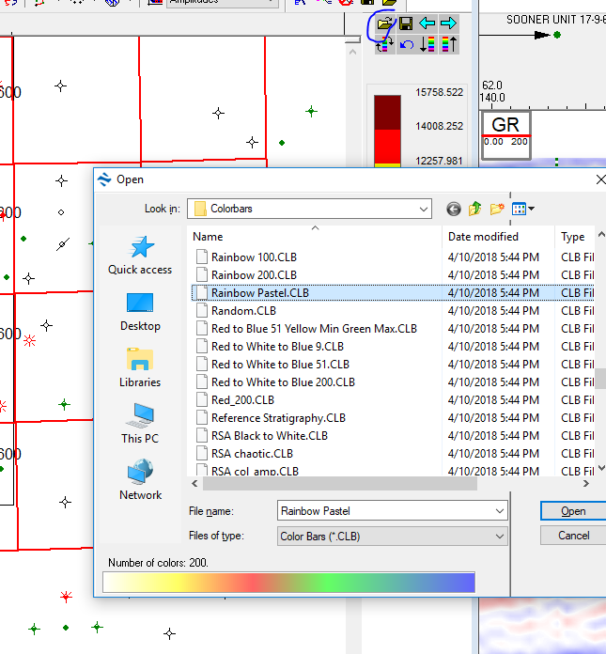
  + 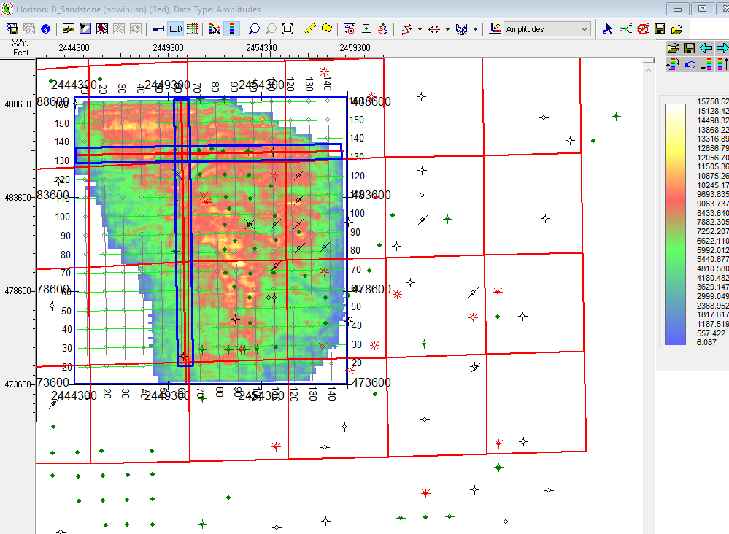
* We can also change from amplitude to time map
* 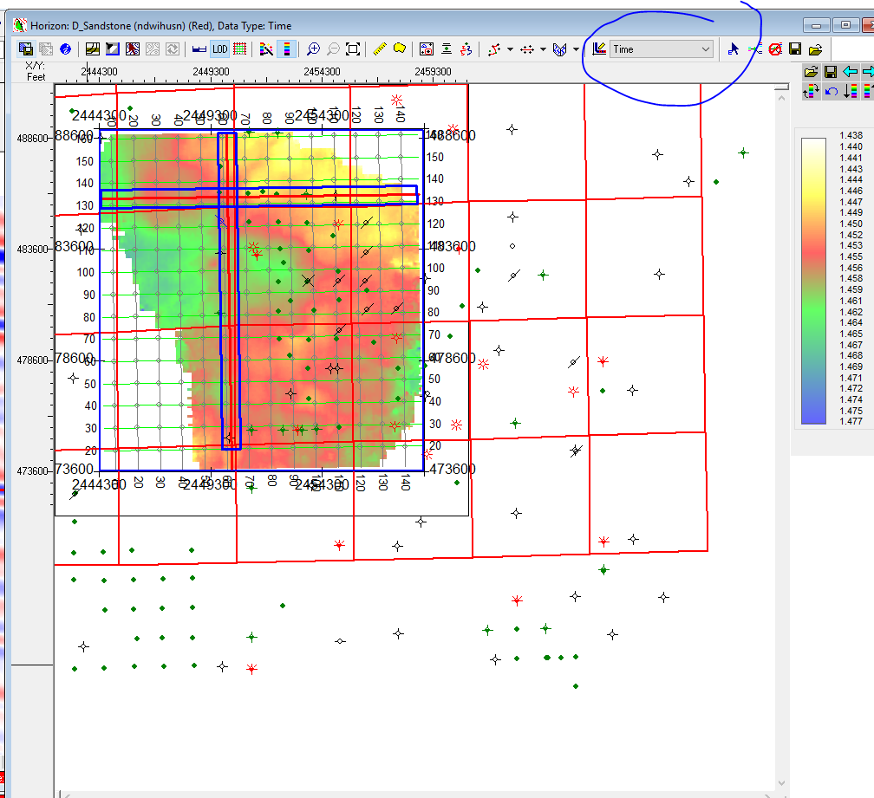
* See the cross section time:
* 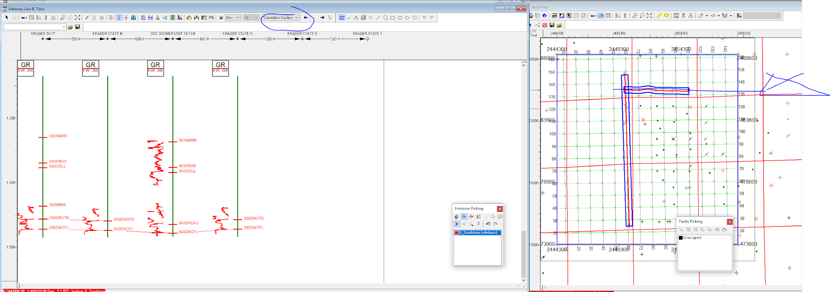
* Projects, rOCK sOLID aTTRIBUTE sOONER 1… Do different attributes
* HOMEWORK
  + Hunstmann, amplitude Map and 3d hunt
  + Every 5th line and do 3d hunt
  + Not faulted… simpler when we get deeper

**3/18/2019**

* Export overlay petra and kingdoms
* View, toolbars
  + 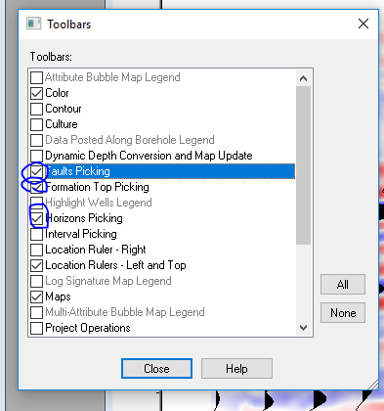
* Get rid of formation tops labels on seismic
  + 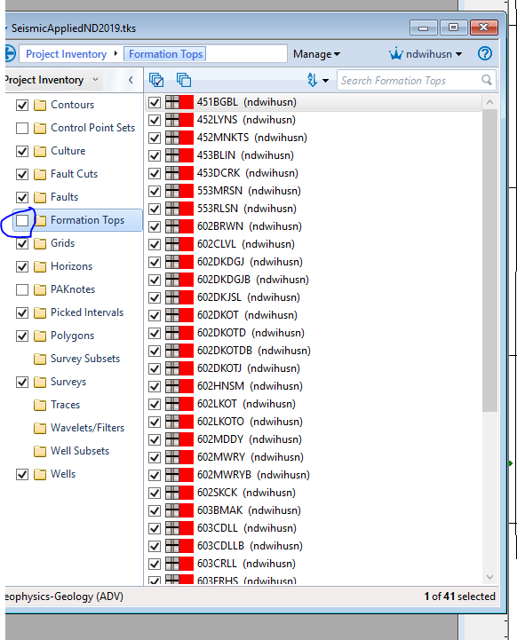
  + We have
  + 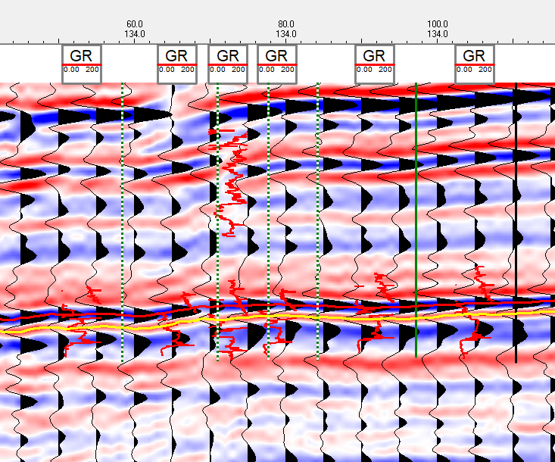
* Logs setting symbol… we only need gamma ray
  + 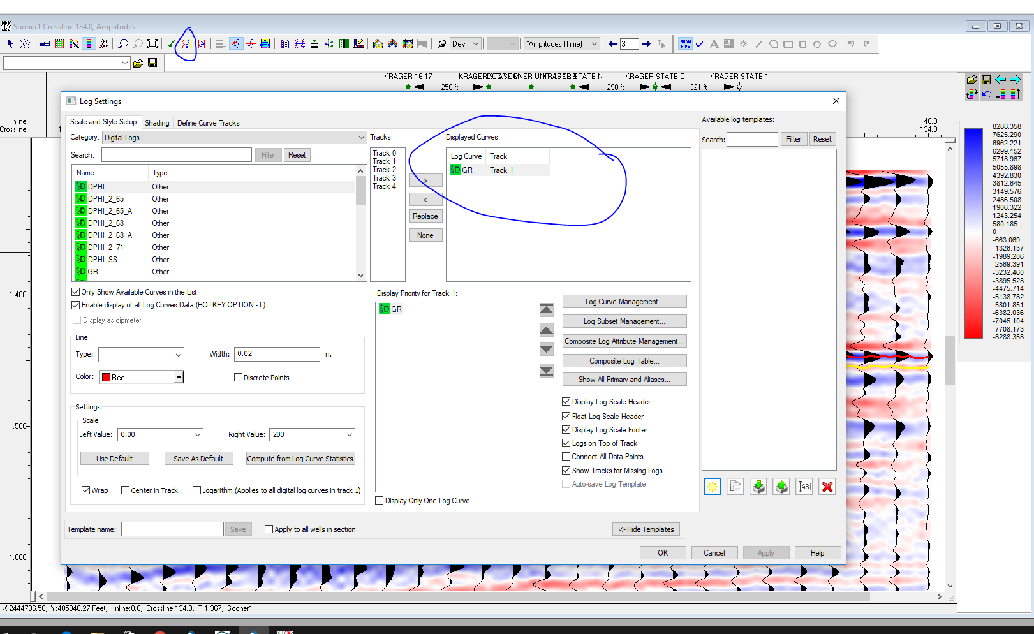
  + Click on shading for gamma ray
  + 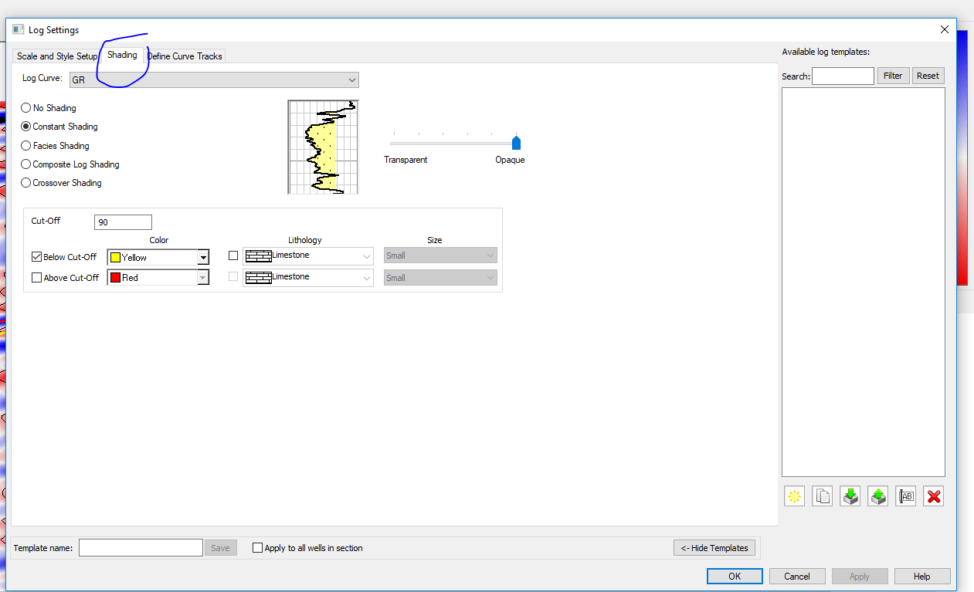
* We can choose different picking types
  + Right click on seismic linke, then picking type, the nchoose 2d hunt, 3d hunt
* Make sure scale is 0 to 300
  + 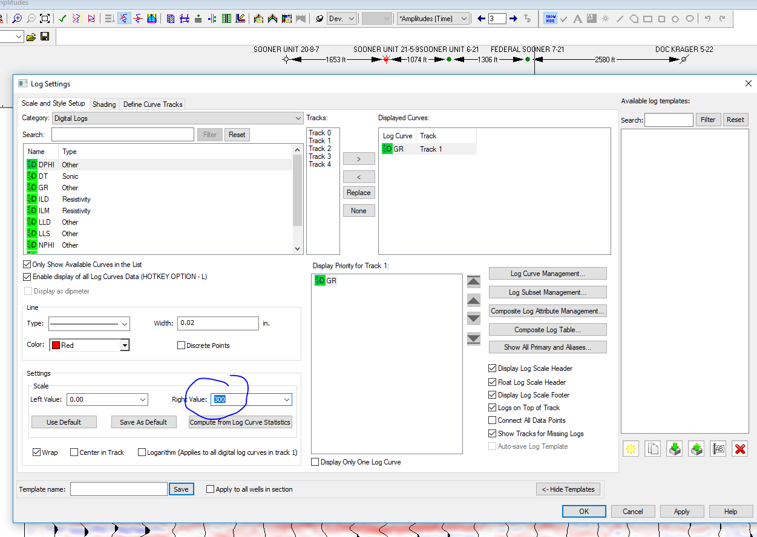
* Tools, depth conversion, compute from isochron maps
  + 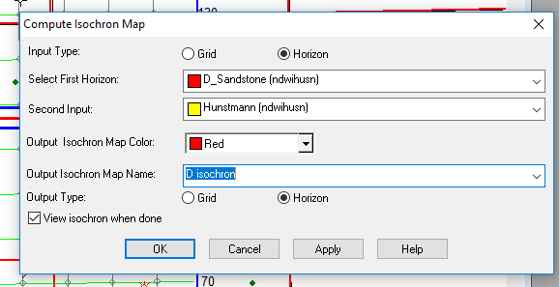
  + 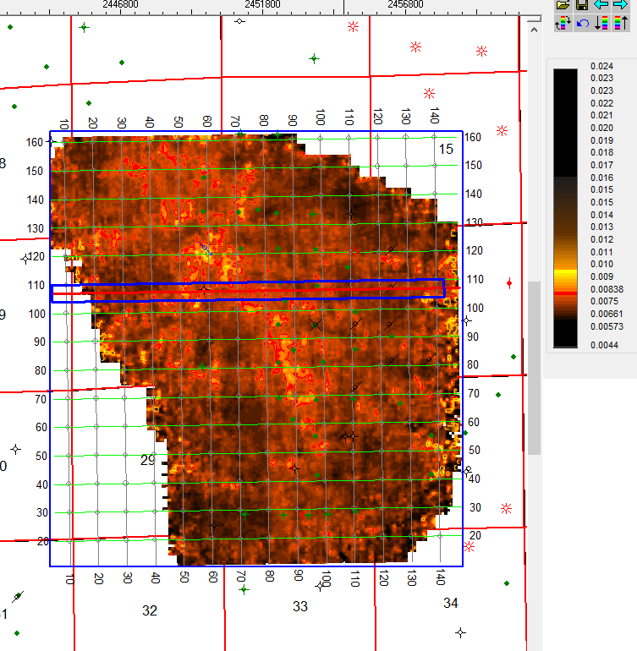
* Tools, calculators, math on two maps to also make isochron
  + 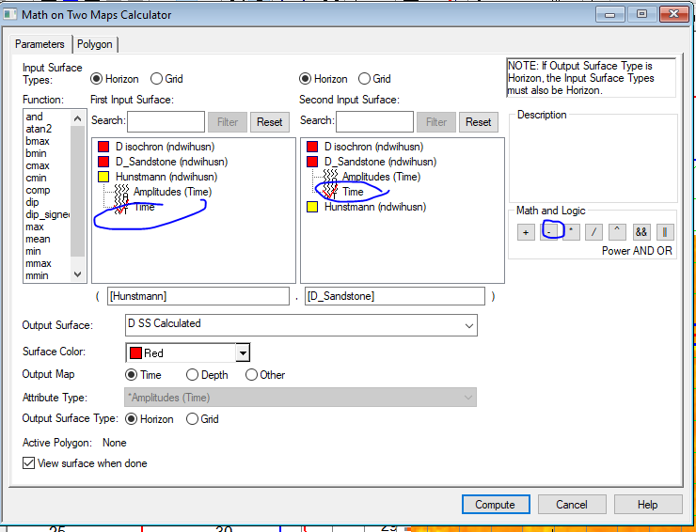
  + 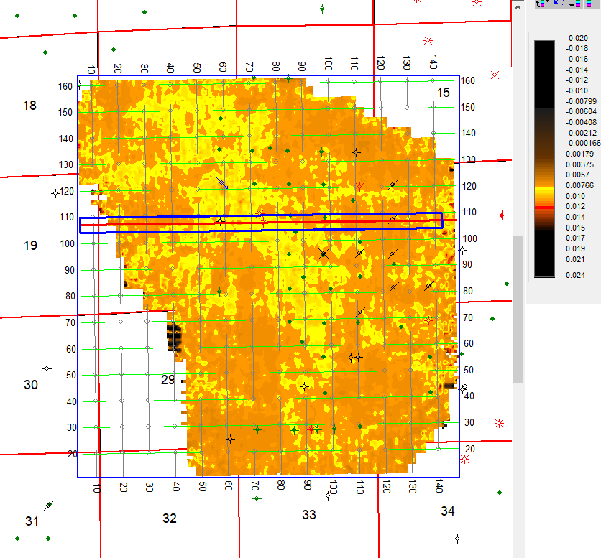
* Contours, compute contours
  + 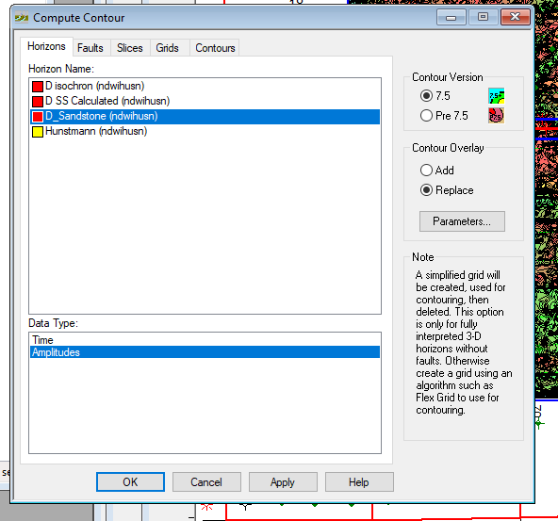
* Save contours
  + 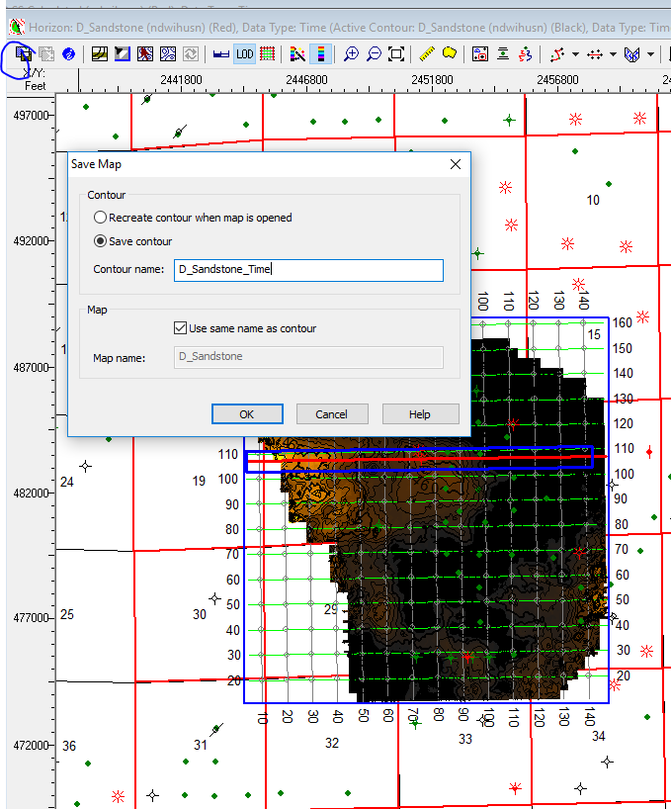
  + 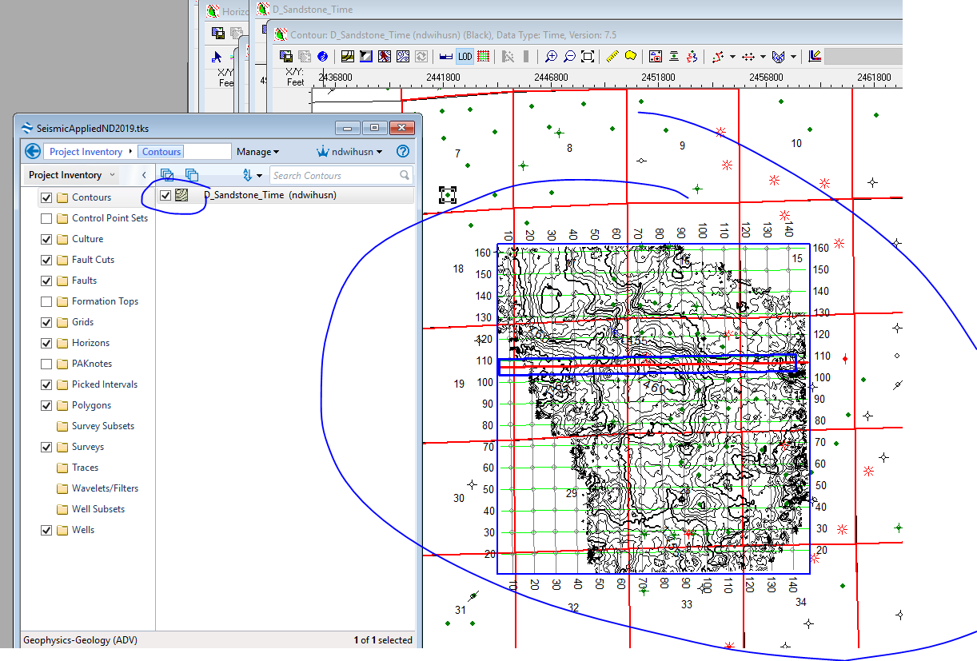
  + 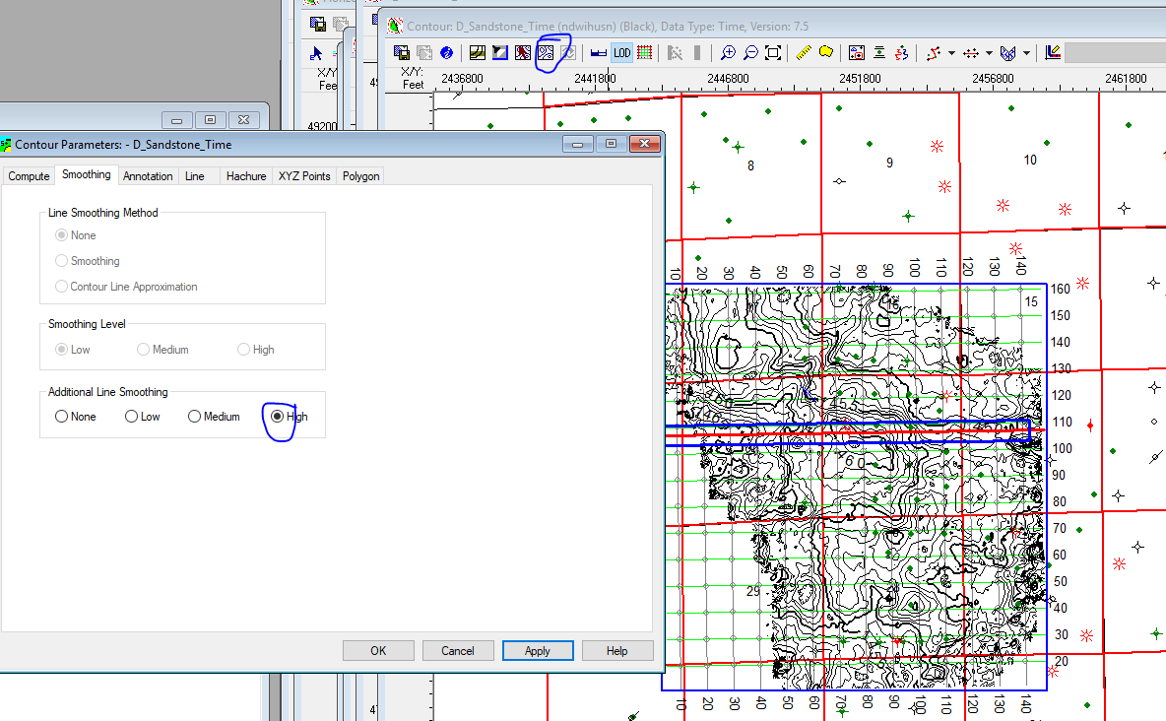
  + Change contour intervals, hit apply before ok
  + 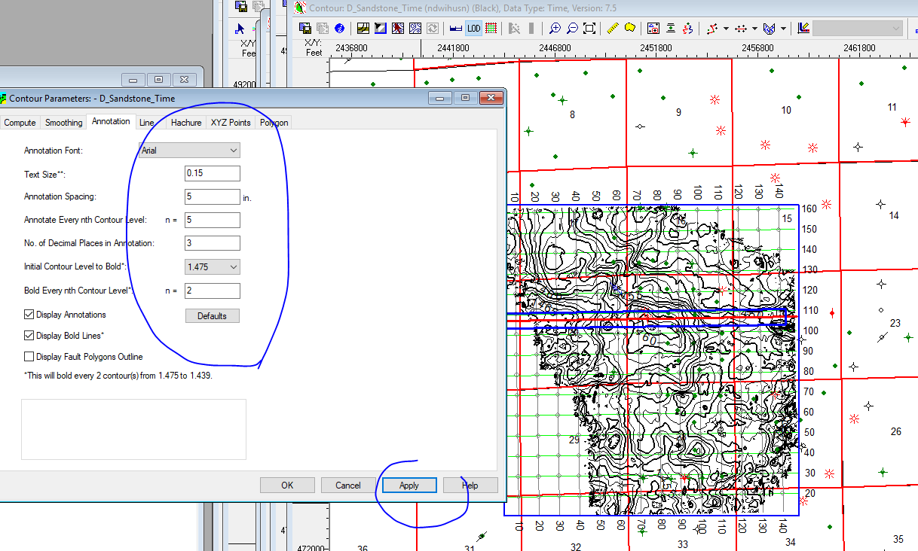
* Create synthetic… go to well 1-28
  + 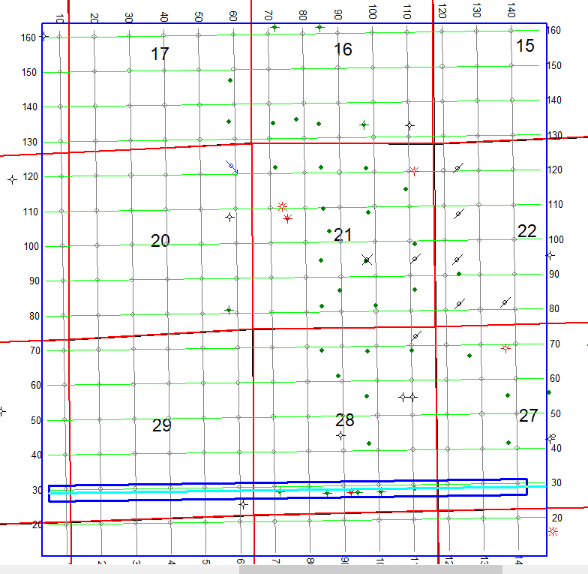
  + Right click on seismic then Generate synthetic to all wells
  + 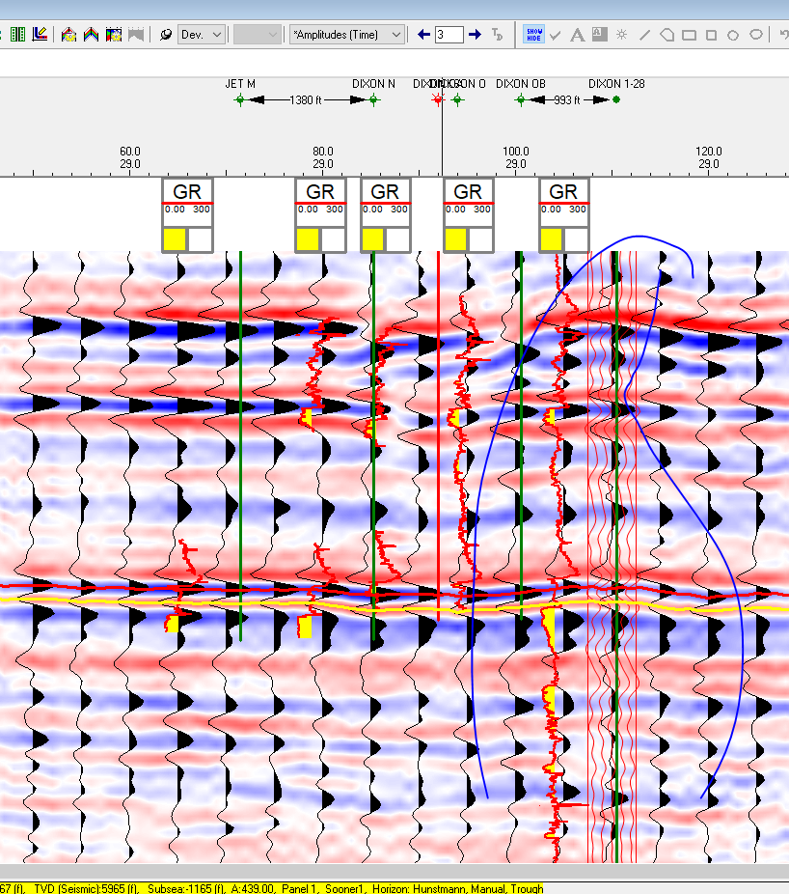
* Highlight seismic
  + Wells, synthetic management...now we have 2 synthetic not 5 synthetics
  + 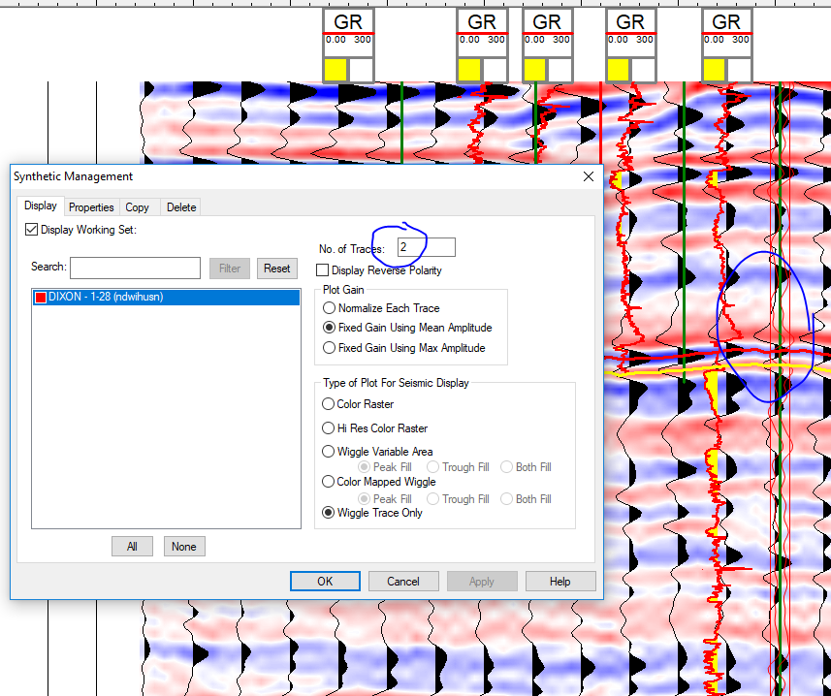
  + 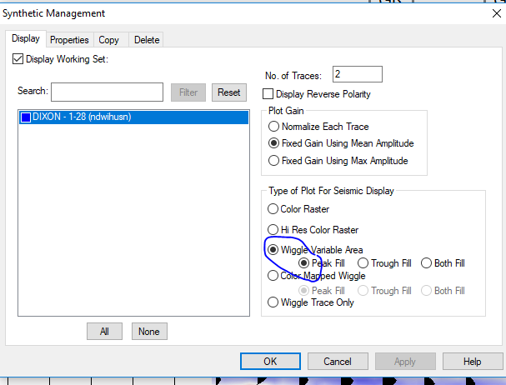
* Tools, depth conversion, compute average velocity map
  + 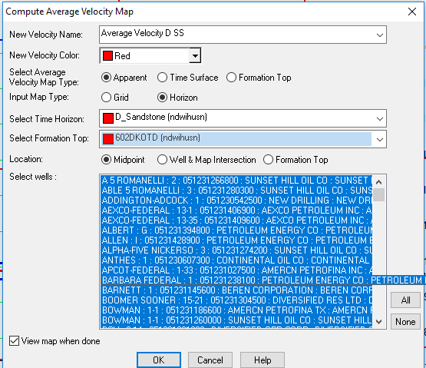
  + 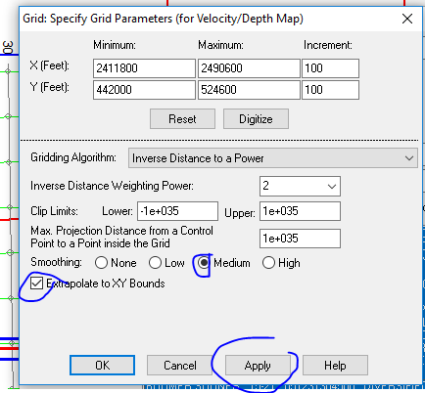
  + 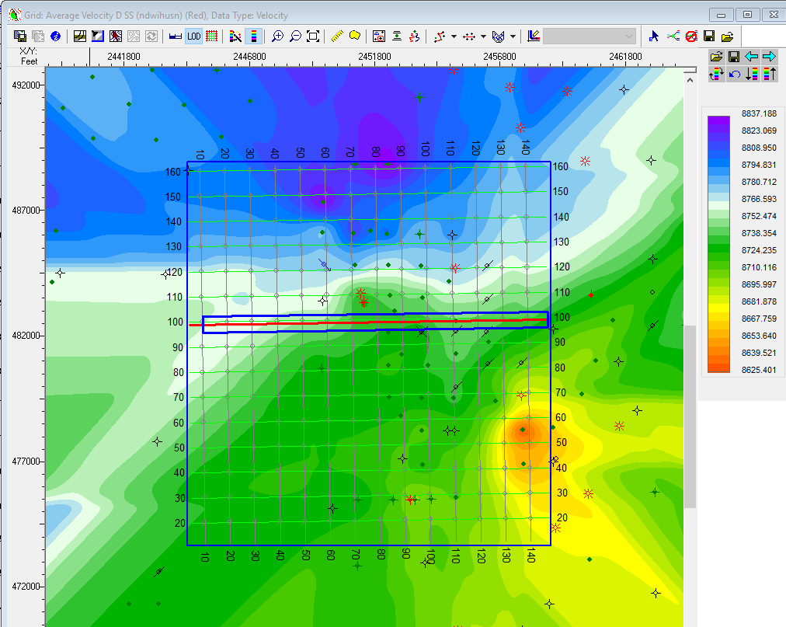
* Tools, depth map by average velocity map
  + 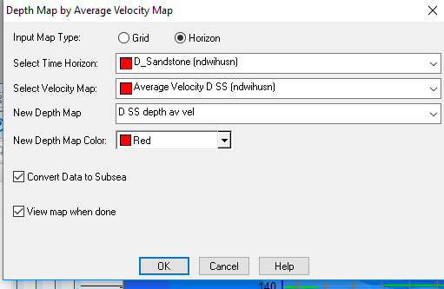
  + 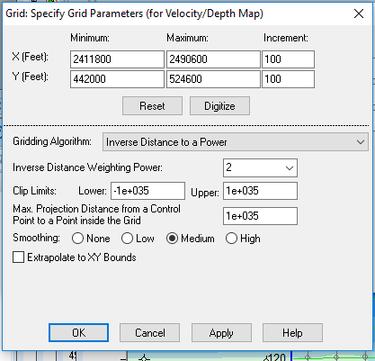
  + Now we have depth structure
  + 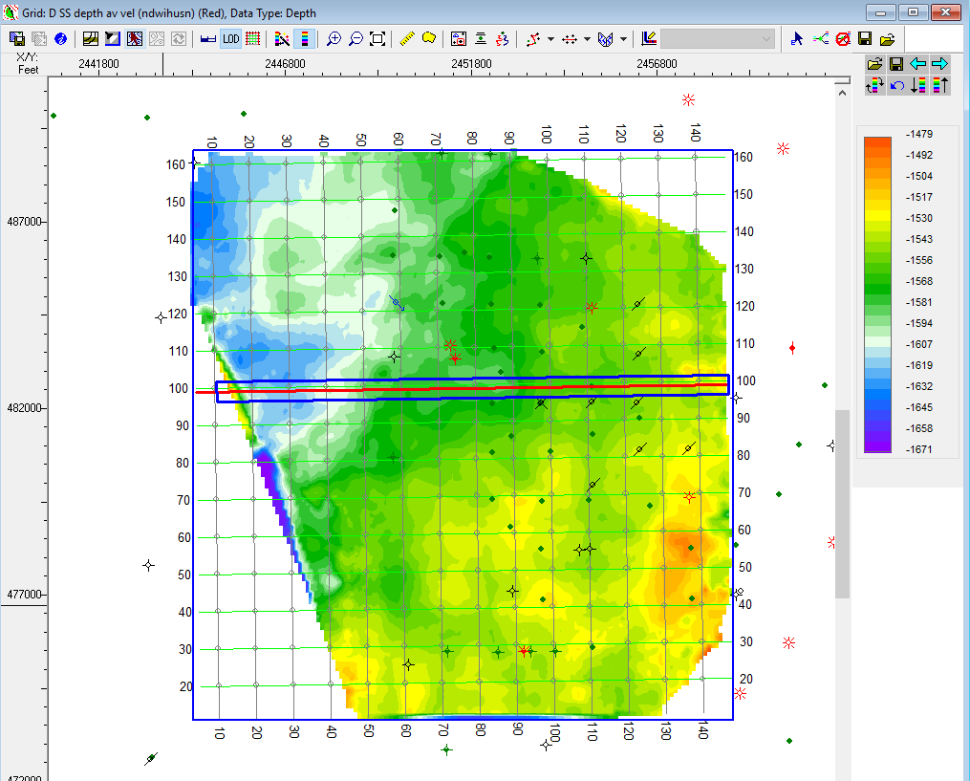
  + Contour with Velocity of D SS
  + Now contour intervals
  + 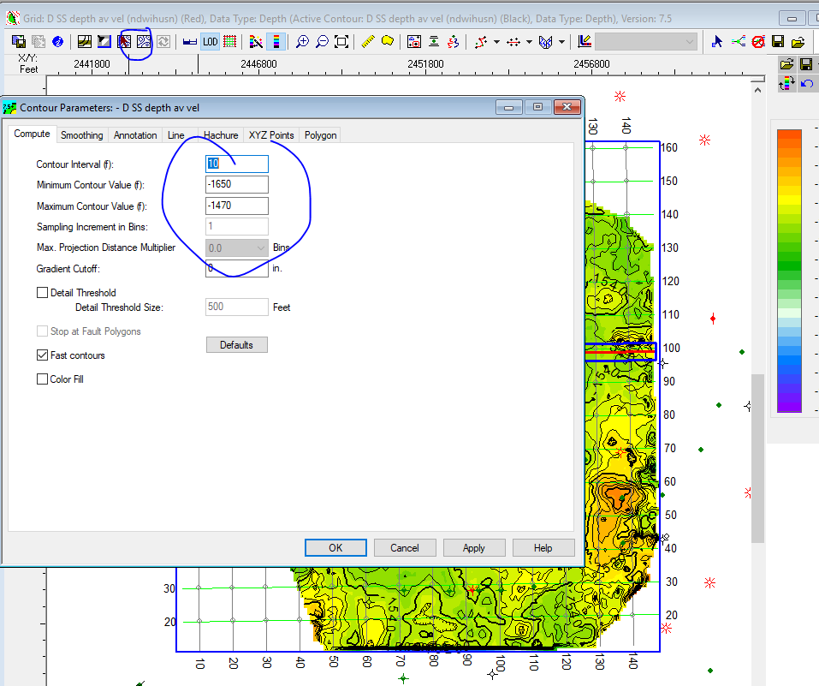
  + Now we have
  + 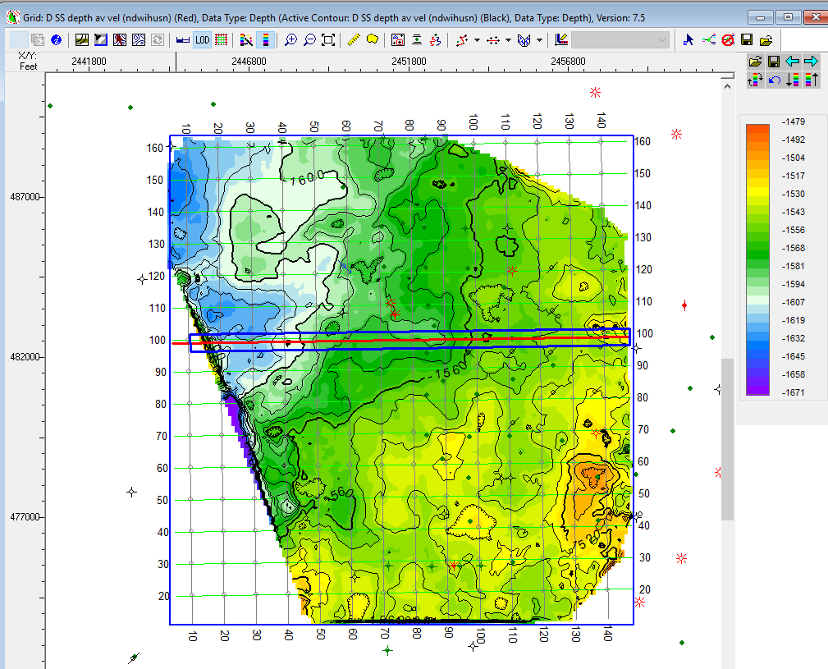
  + 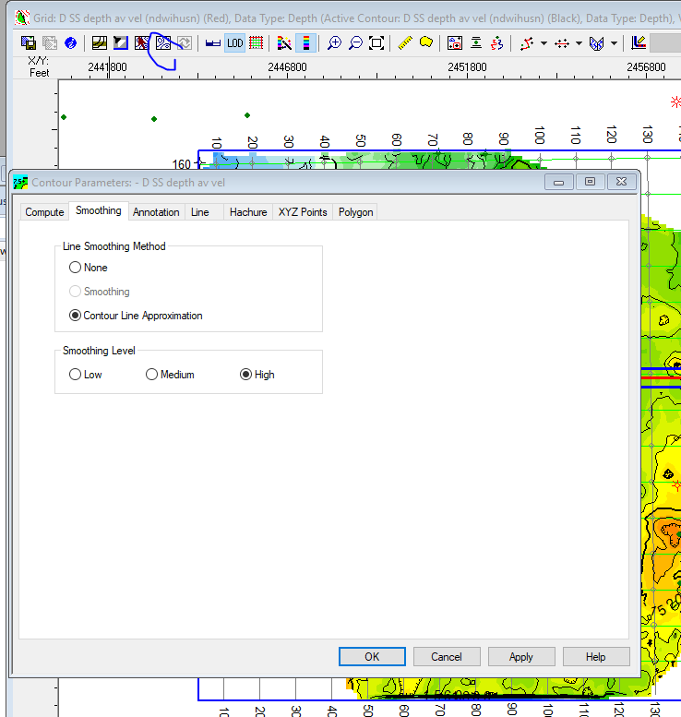
  + Save it
  + 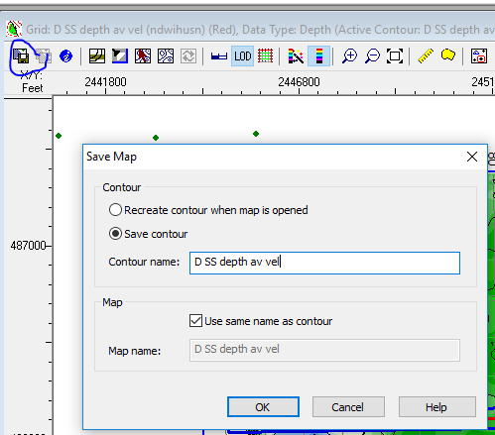
  + Now we have it here
  + 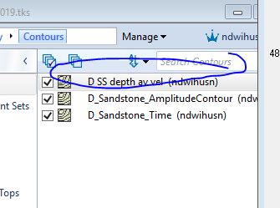
  + Final map:
  + 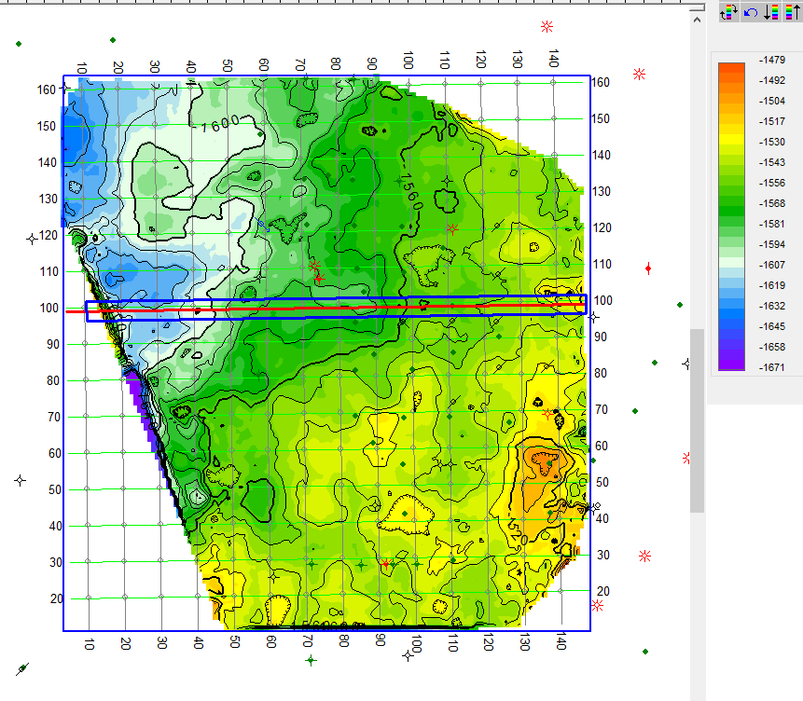
* Tool, depth conversion, depth map by shared T-D chart
  + 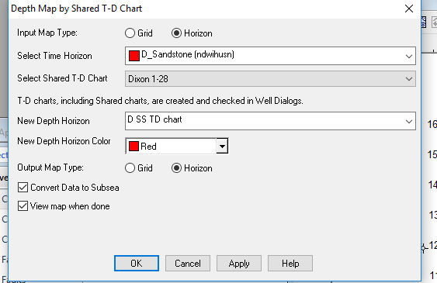
  + This map is not too good...so different than the one in petra and the one we had from previous step
  + 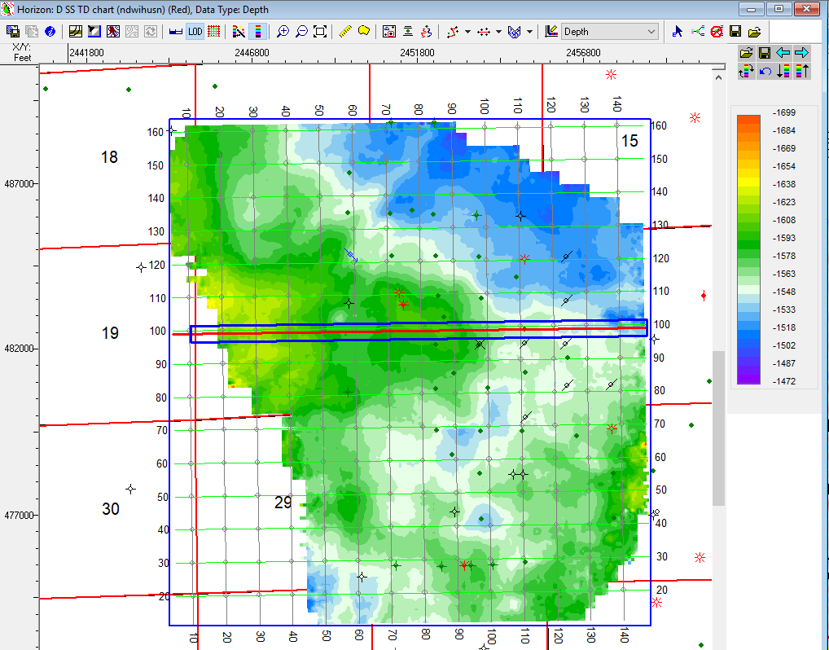
* **HOMEWORK** Due April 1 for the next two weeks… work on blue horizons
  + Horizons, new horizons, name niobrara

**4/1/2019**

* Make faults
  + Click on the map
  + Right click on map, Display arbitrary line ...digitize choose first option
  + Click on fault surface management, and create make fault name “A-dte” then start picking fault
  + View, toolbars, turn on fault pickings
* Heave (horizontal displacement) and throw (vertical displacement)
  + 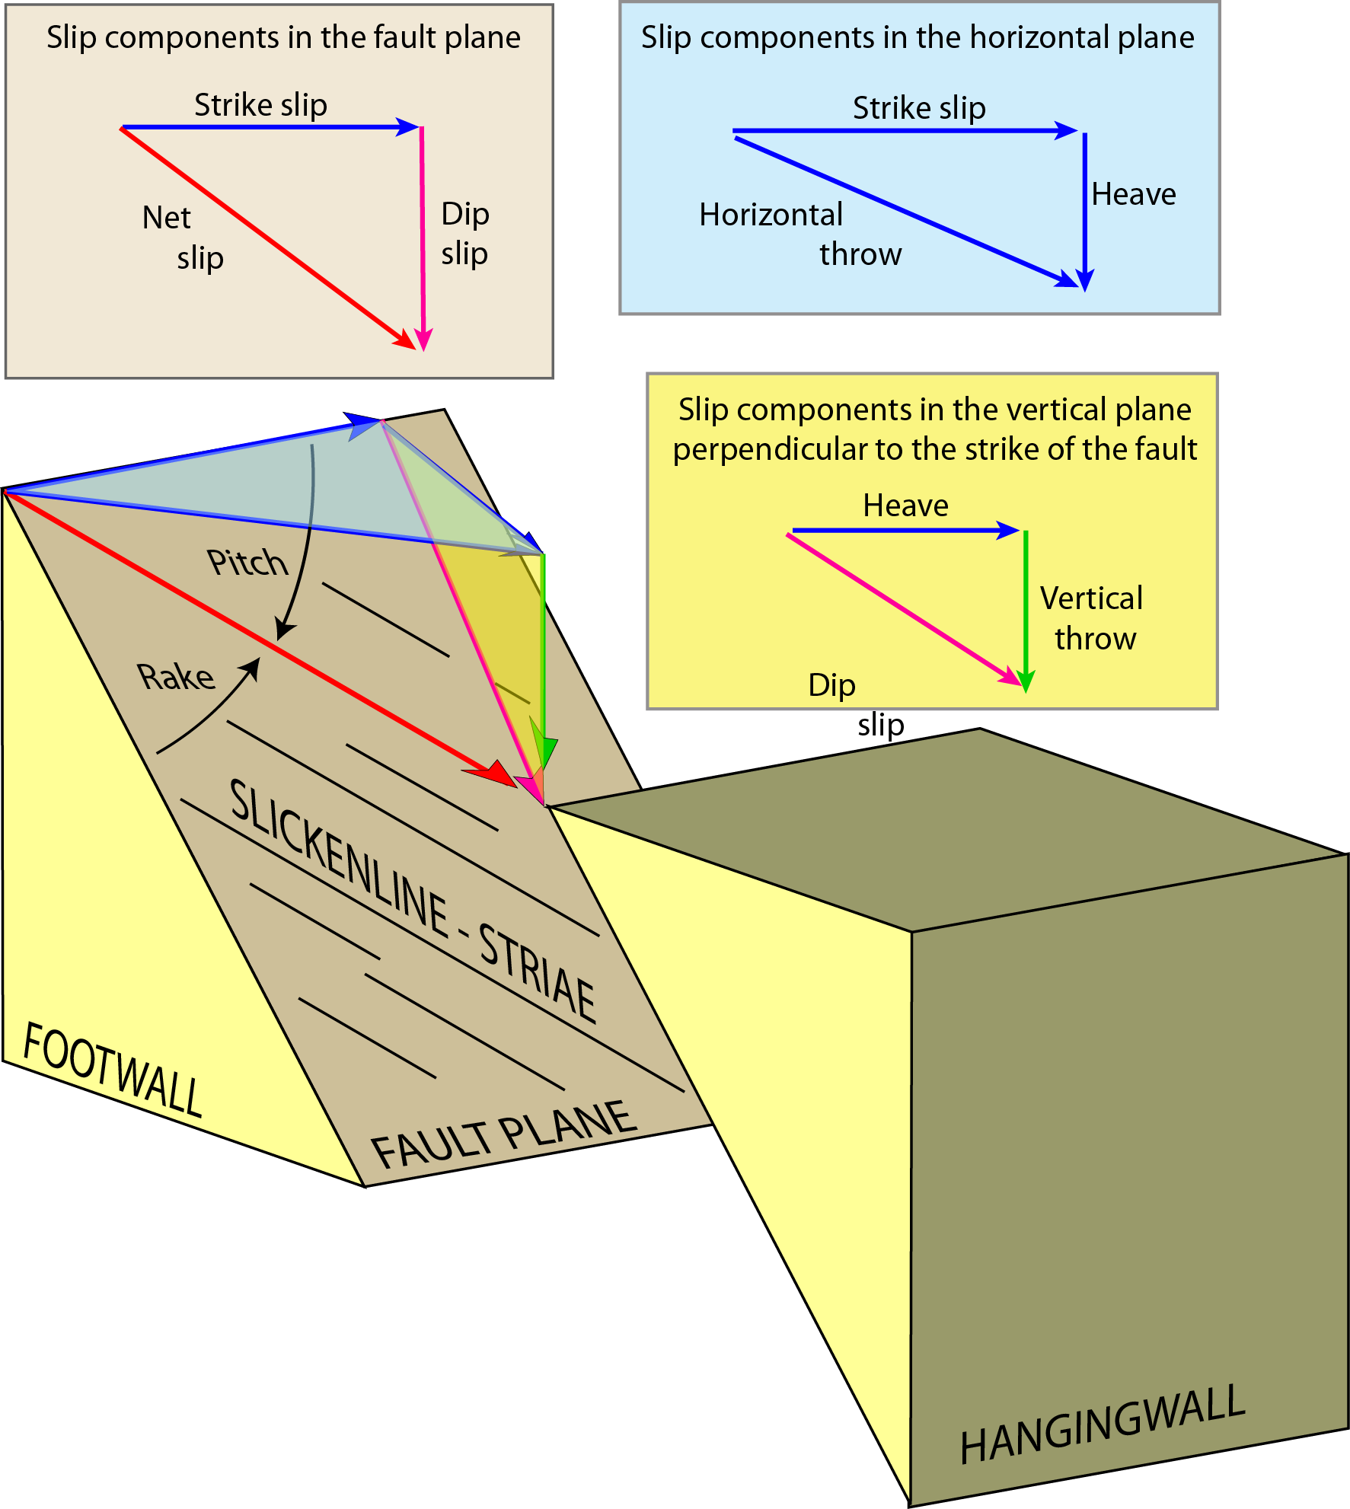
* **Homework:** pick fault in the south, the long one,, and base of niobrara then make thickness map
* 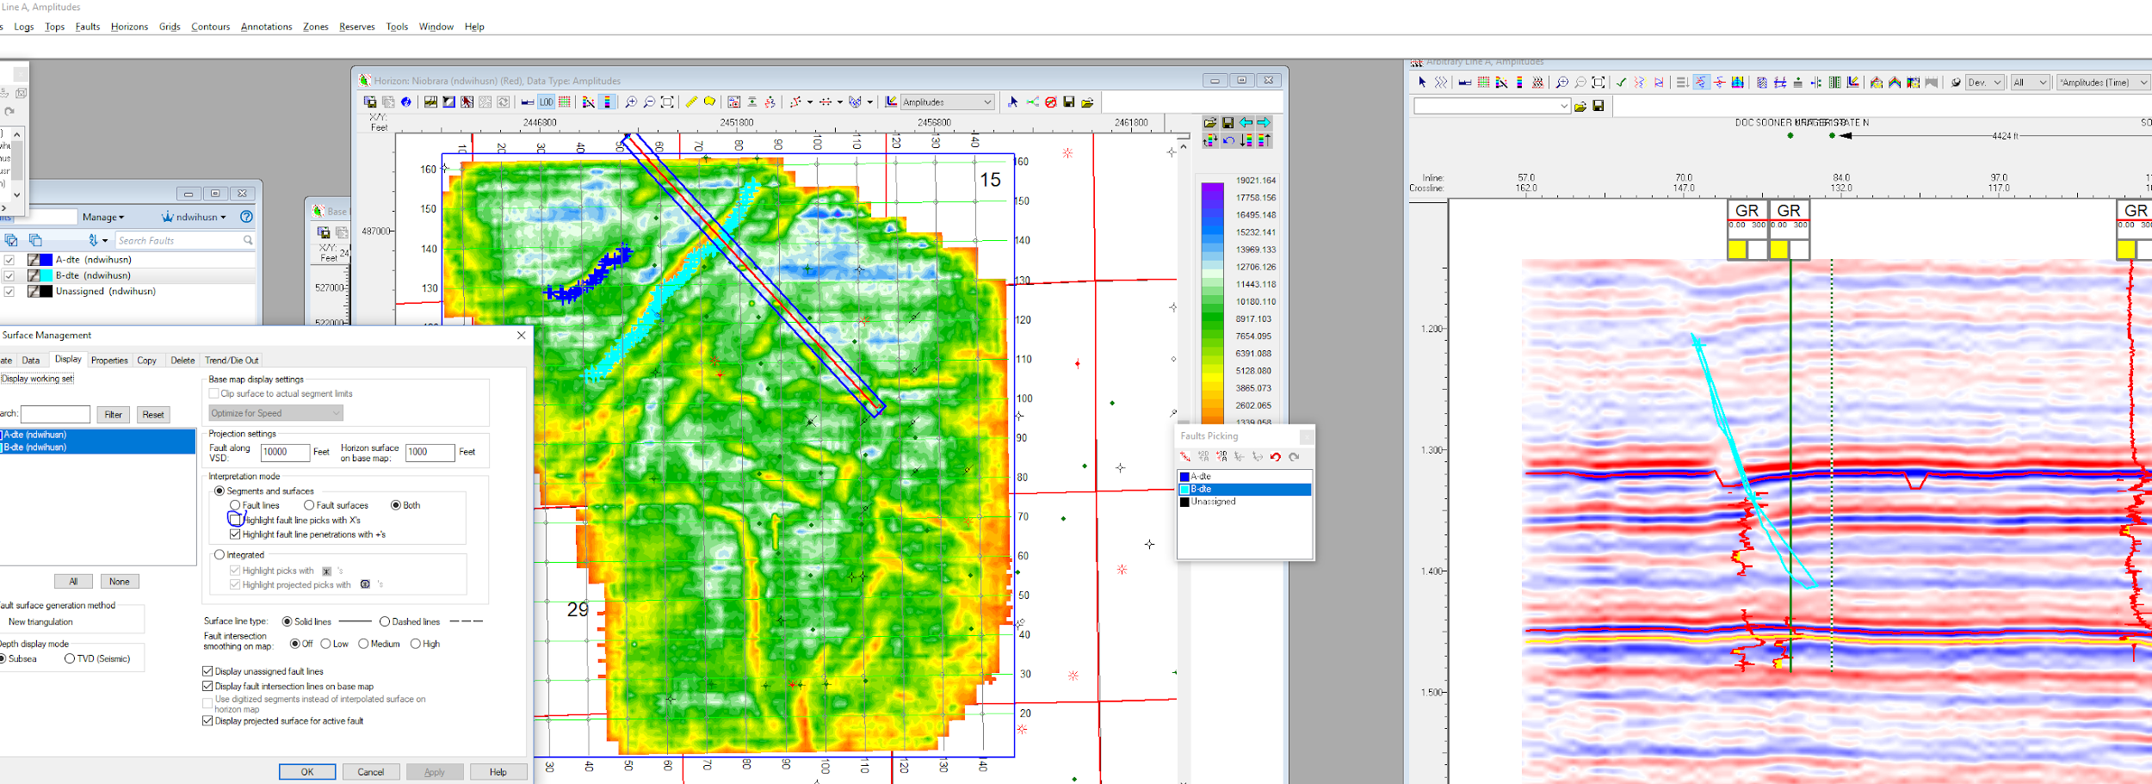
* Help, help center
  + Quicklinks, get started
  + “Rock solid attributes”
  + “Vupack 3d visualization”
  + **Final project** → do something with attribute “geologic uses of rock solid attributes”
* Project, rock solid attributes
  + Click sooner, then next
  + Geometric attribute, then Similarity to highlight discontinuity helpful for Niobrara
  + Next, next, 32 bit, next, then finish
  + Horizons, extra data type
  + 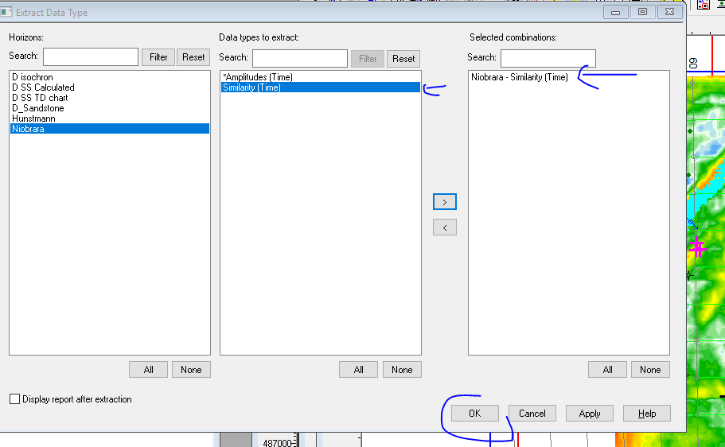
  + Now we have similarity that mutes or softens all the noise and show faults...amplitude also shows the same thing
  + 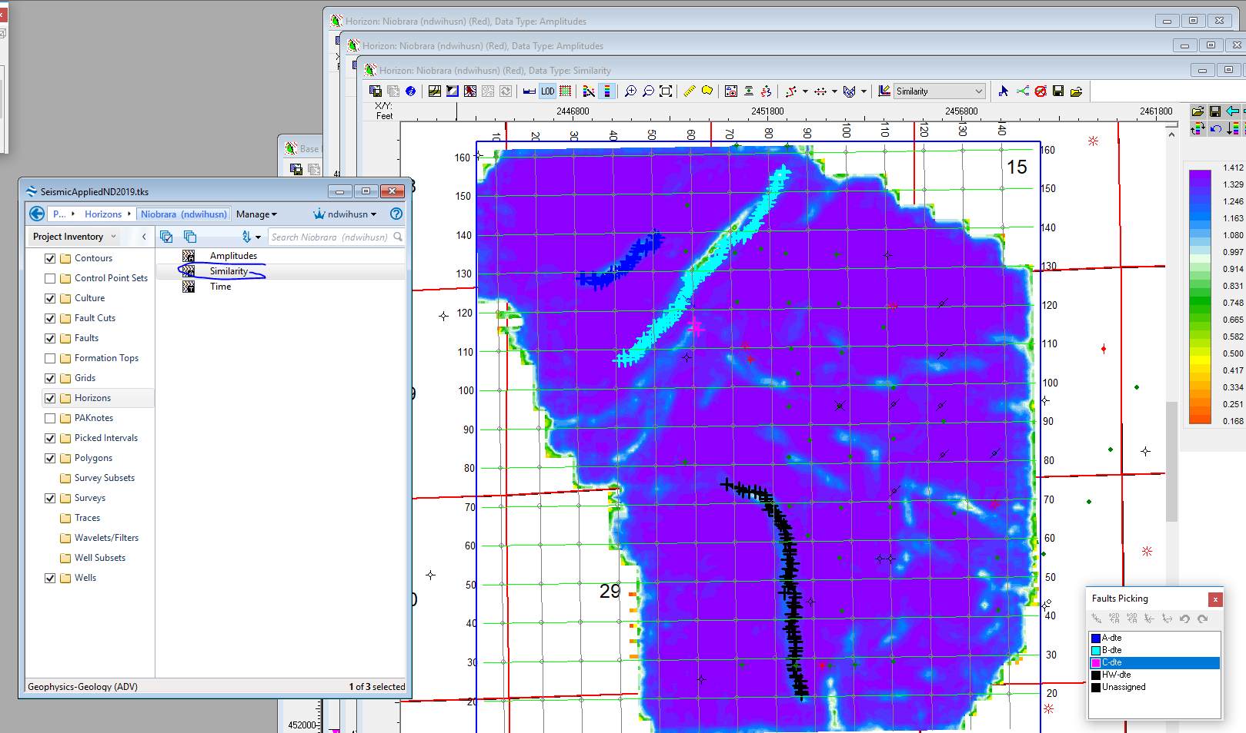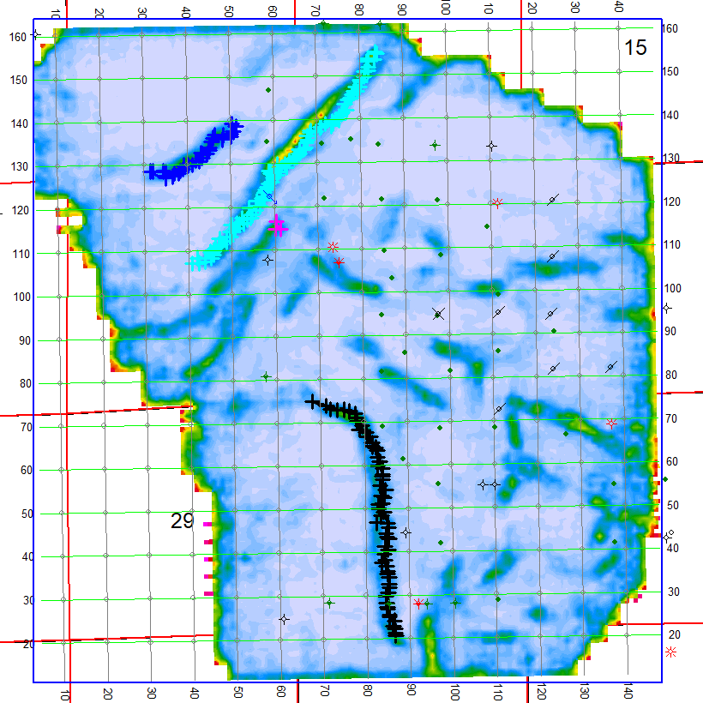
* Do most negative curvature attribute
  + Project, rock solid attribute, next next next
  + 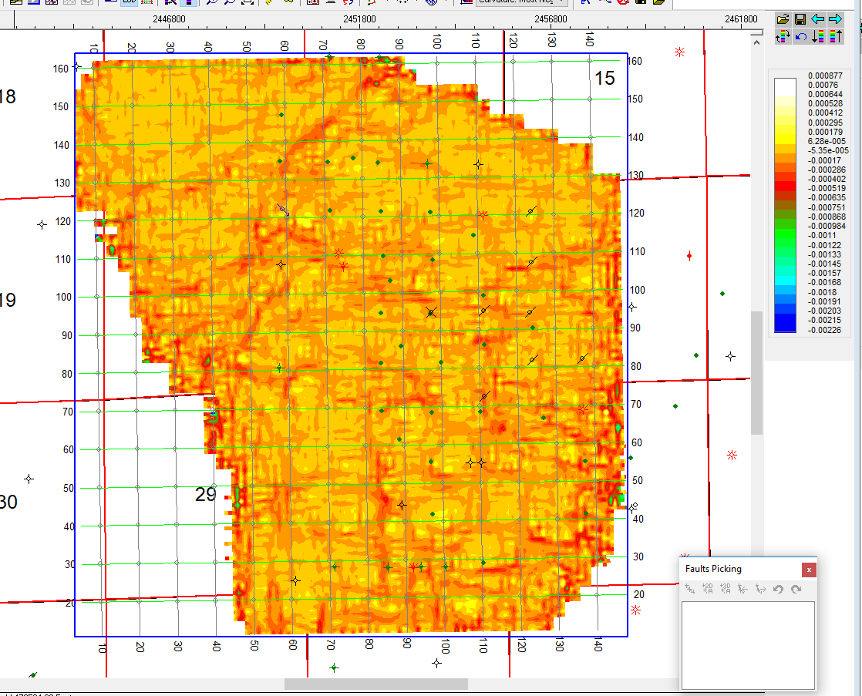
  + ^ shows alot of acquisition footprnt. This is why geophysicist should be careful in acquisition footprint
* Display timeslice… right click on siesmic line at 1.3 second, then display time slice at 1.3 seconds
* Do D SS Spectral attributes
  + Display horizons, D_sandstone amplitude horizon
  + 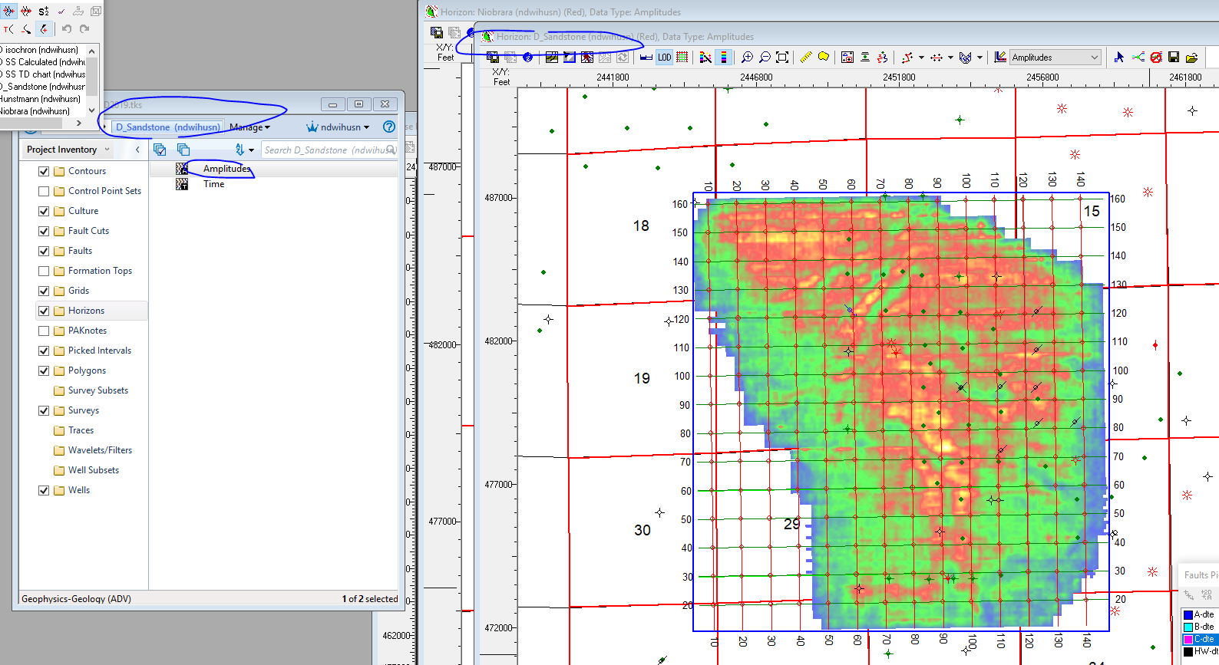
  + Project, rock solid attributes,
  + Spectral Decomp Attributes
  + 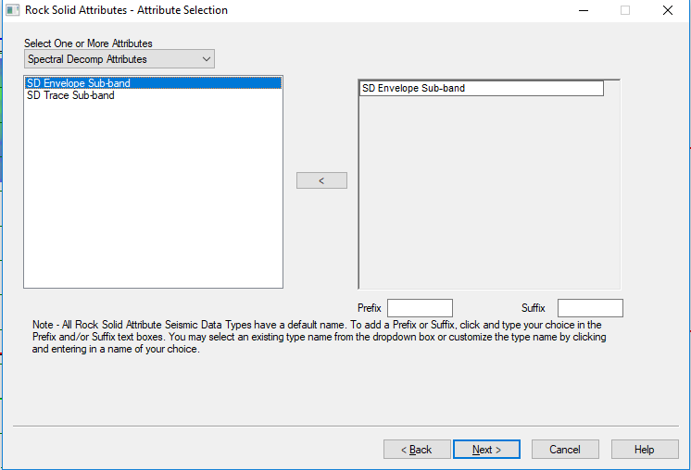
  + Next, then click spectrum analysis then apply… show how we want to group the frequencies, and click linear scale
  + 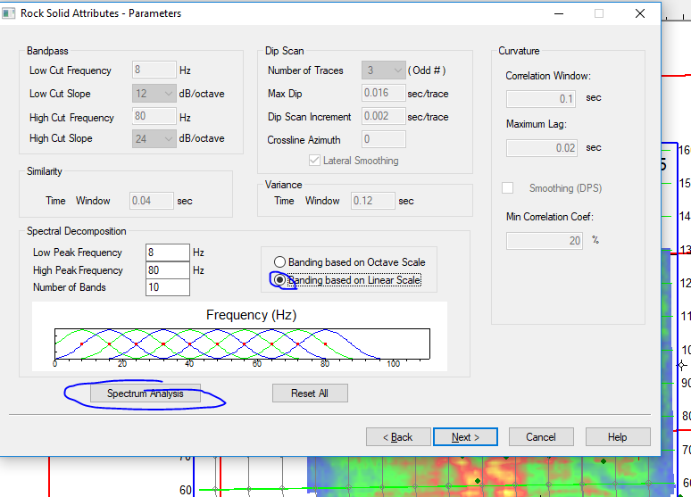
  + 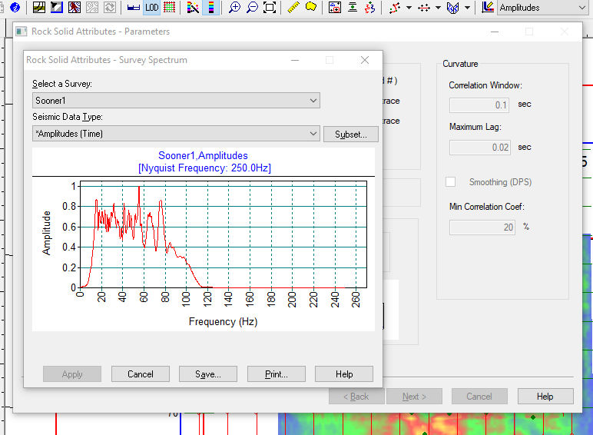
  + Click next, 32 bt
  + Next
  + Horizons, extract data type,
  + 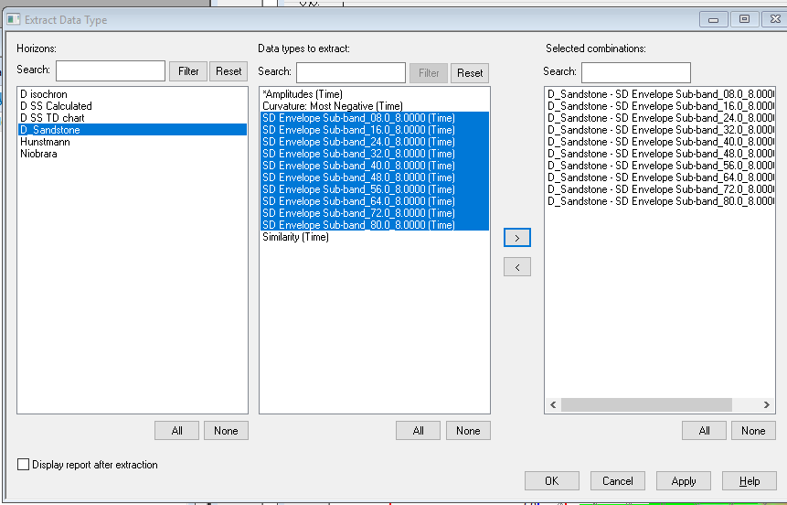
  + For 8 frequency:
    - 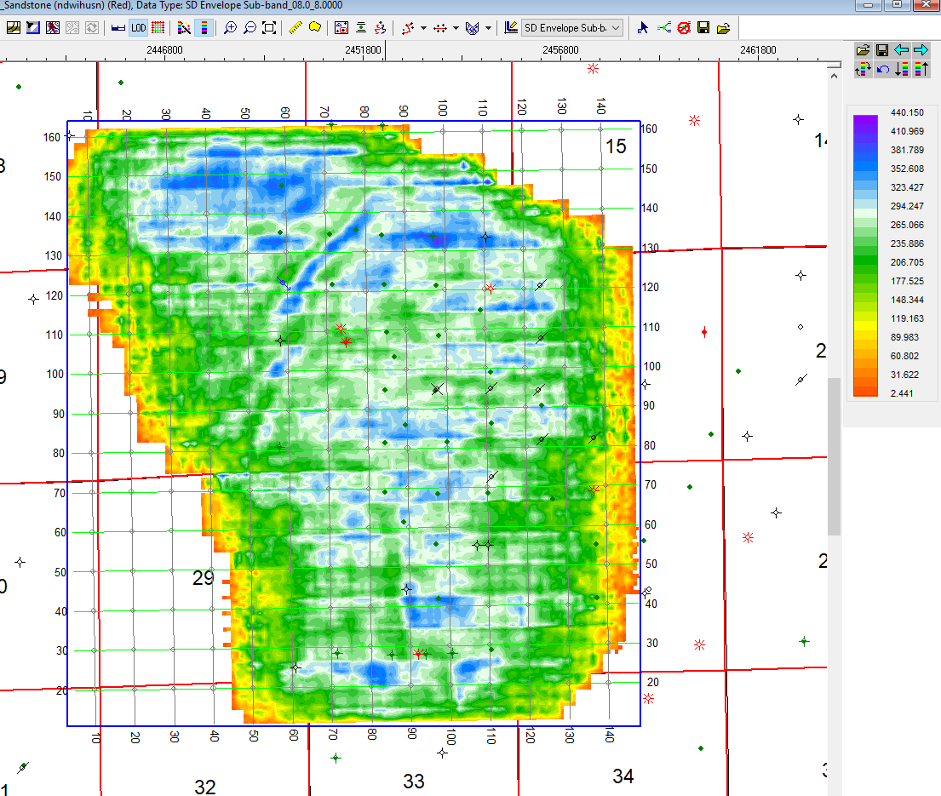
  + For 32 frequency: using colorbar SEG Instantaneous frequency
    - 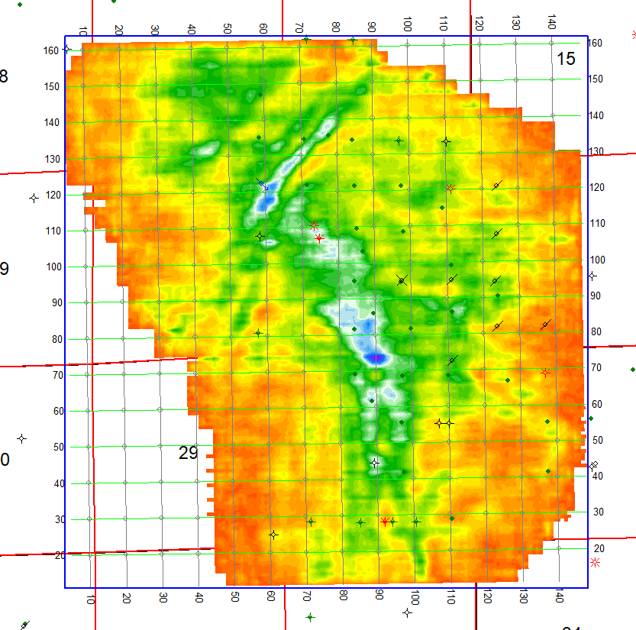
* Project, VuPak
  + 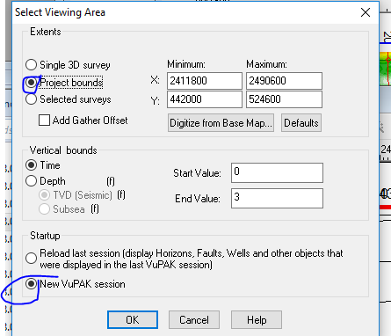
  + Select slice, 1.33
  + 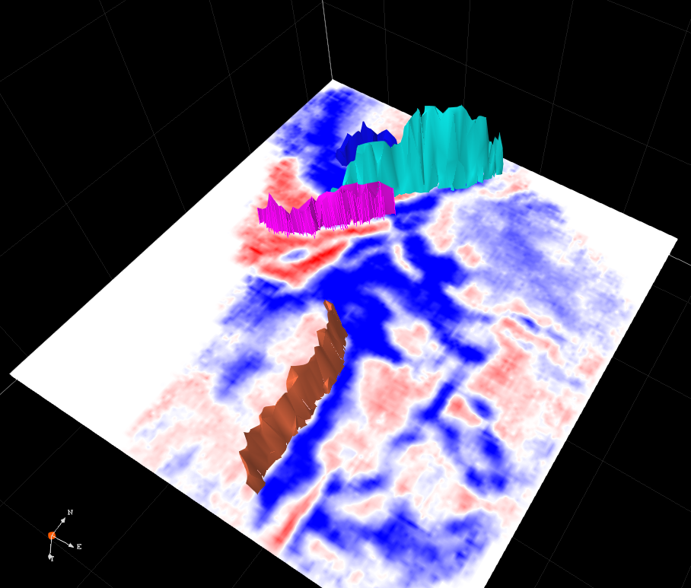
  + Select seismic
    - 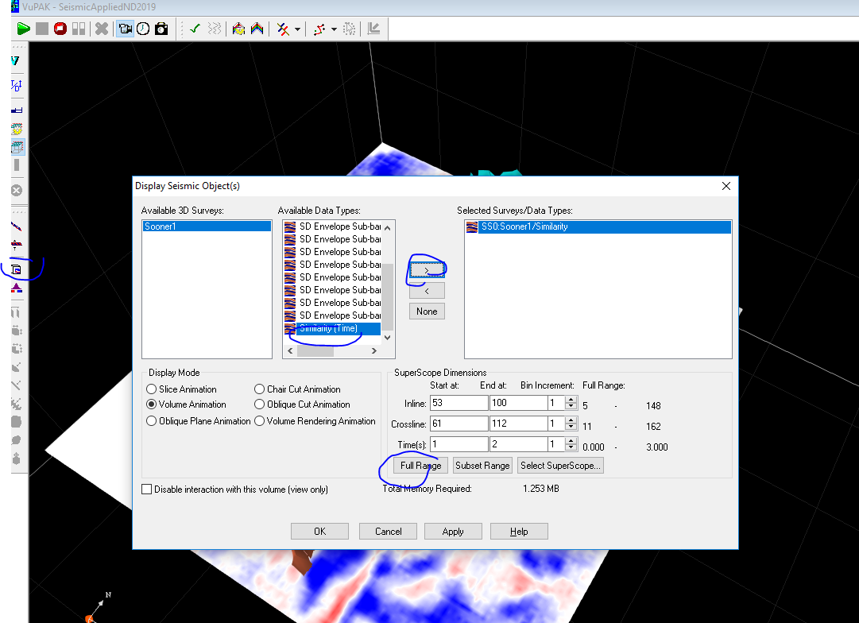
    - Change colors
      * 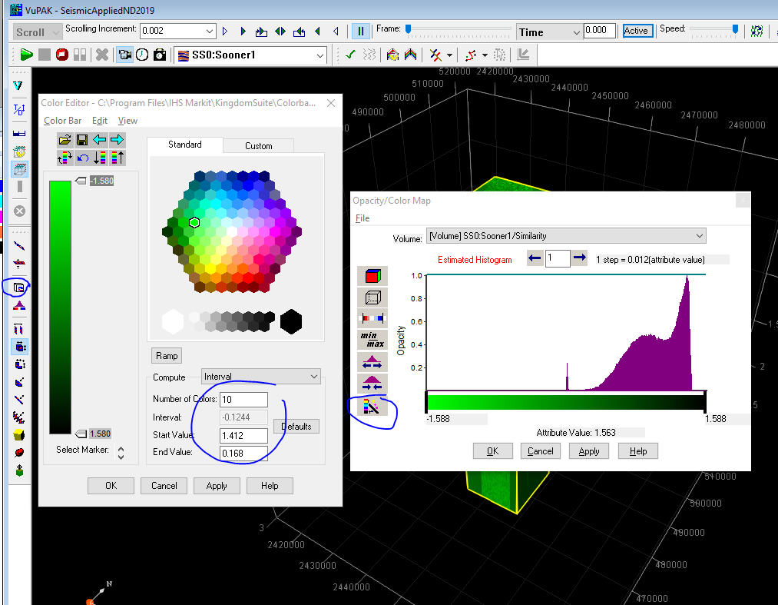
      * Choose SEG Attribute color map
      * Play around with the time map

